This Spring half-term in Year 2 we will be learning... l
Art
The children will look at portraits this half term, starting with self portraits. We will focus on each element of the face to build up to the full face. By exploring portraits of monarchs we will experiment with different pencil techniques and paint.
Maths
Children will continue to develop their fluency skills with the mastering number program. We will begin learning about measures and applying our mathematical skills to different contexts of measures. We will also be going deeper into calculations, finding efficient methods for addition and subtraction.
English
Literature Works or Read Write Inc will be taught daily incorporating whole-class guided reading sessions as well as children being heard to read individually. They will focus on fiction writing as well as recounts. We will be learning to use varied sentence openers, conjunctions, adjectives and adverbs in order to develop writing style. Children will also become familiar with non-fiction texts relating to our Kings and Queens topic.

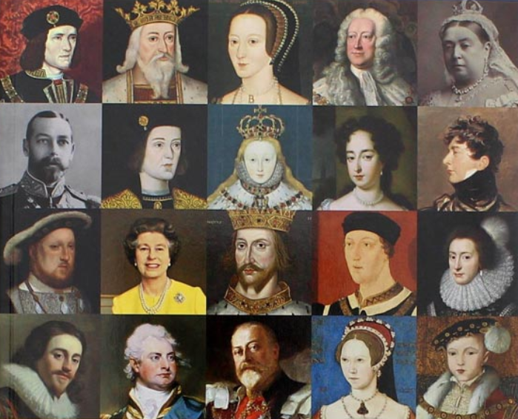

Kings & Queens!

Computing
In Computing, children will be using search engines on the internet to help them research information about monarchs of the past. They will then word process this information. They will revisit e-safety during this time too.
History
In History children will learn about the history of the British Monarchy, in particular, different Kings and Queens that have ruled. They will learn about how life during specific reigns differs to our lives today.
Year 2 - Spring Term 2 2024

Science
In science we will continue to focus on everyday materials, including inventors and scientists from the past, and will then move onto learning about living things and their habitats.
R.E
In R.E children will be taught about salvation and discuss what it means for Christians to be saved.

PSHCE
In PSHCE children will learn about living in the wider world by understanding key concepts such as money and work. We will also learn about keeping safe.
Music
This half term we will continue to have our Music lessons from Mrs Milner, focussing on pitch, rhythm and tempo. We will also focus on music appreciation and will be listening to baroque music amongst other eras and styles.
P.E
The children will take part in 2 P.E lessons each week. One lesson will be skills based, led by a PE specialist and will focus on multi-skills. The second lesson will emphasise the importance of fitness for being healthy.

S

Additional Information:
Reading:
Please hear your child read/read with your child every day and record this in their yellow reading diary - remember, your child is entered into the Reading Raffle each time they have their reading recorded in their diary. School library books are changed on a Wednesday.
P.E:
There are two P.E. sessions per week. Your child should continue to dress appropriately for PE on their allocated PE days. PE uniform should consist of black/blue jogging bottoms, white t-shirt and school jumper as well as trainers.
Water Bottles and snacks:
Please continue to send your child to school each day with a named water bottle.
At morning break time children can have a healthy snack such as piece of fruit or vegetable but could also include something like breadsticks or a breakfast bar which should be brought in from home.

Finally, if you have any concerns or questions regarding your child, please do not hesitate to contact us by email or by phoning school.
Year2home@heddon-school.co.uk

Mrs Southern and Mrs Leja

