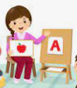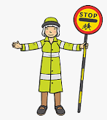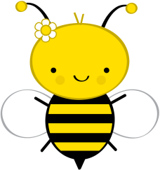

**Literacy**

Children will listen to a range of texts and will explore how stories and non-fiction texts are structured and organised. They will continue to blend phonemes to read simple words and to read some words by sight. The accuracy of letter formation patterns will improve and they will learn how to construct and write simple sentences. They will also learn to identify and match capital letters to lower case letters.

### Physical Development

This half term the children will:

* Learn about different food groups and the importance of a healthy diet
* Learn about food preparation; hand hygiene, using tools effectively and safely etc.
* Continue to develop overall body strength, coordination, balance and agility through physical activities and large scale construction
* In PE, children will continue to develop multi skills through NUFC and will explore Yoga during their second session.

**Expressive Arts and Design**

Children will:

* Continue to develop their colour mixing skills by exploring shades of colours
* Draw/paint/construct different representations e.g. people, vehicles, animals, buildings, plants etc
* Look at winter landscapes and create representations of winter trees
* Explore percussion instruments; sort, group and match sounds

### Communication and Language

This half term we will focus on describing events in more detail and using sequencing language when retelling our own stories. Children will be encouraged to use talk to help solve problems, organise their thinking and activities, and to explain how things work and why they might happen.

### Personal, Social and Emotional Development

Through circle time activities and group work, the children will be encouraged to:

* Express their feelings and consider the feelings of others
* Identify and moderate their own feelings socially and emotionally; discussing and exploring strategies to help them manage their emotions
* By identifying and sharing their strengths and successes they will learn to see themselves as valuable individuals

**Understanding of the World**

During this topic, children will:

* Continue to explore the natural world around them and investigate the changes of the seasons; investigate snow and ice
* Talk about the lives of people around them and their roles in society
* Use the local area for exploring both the built and the natural environment
* Express their opinions on natural and built environments
* Use technology to support their learning e.g. program a Beebot, use computing programs to develop mouse control and keyboard skills

###### **Mathematical Development**

Children will be encouraged to:

* Continue to read, write numerals to 10
* Understand value of numbers to 10 and use vocabulary to describe sets e.g. more, fewer, equal to, whole, part
* Develop understanding of time; sequence events, describe daily routines, learn to read o’clock times on an analogue clock
* Compare length, mass and capacity and use language to describe them e.g. long/er/est, short/er/est, heavy, light, full, half full, empty, more, less, equal to etc.
* Recognise and name coins, total coins to 10p

### Additional Information

**PE:** Reception –Monday and Tuesday (NUFC)– come dressed in PE kit

**Tapestry**: Please continue to share home learning and experiences via Tapestry.

**Events:**

**Exploring the Village -** As part of our topic, Reception will learn about road safety and how to cross the road safely outside school.

**People Who Help Us**

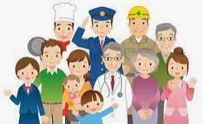

**Reception**