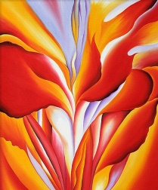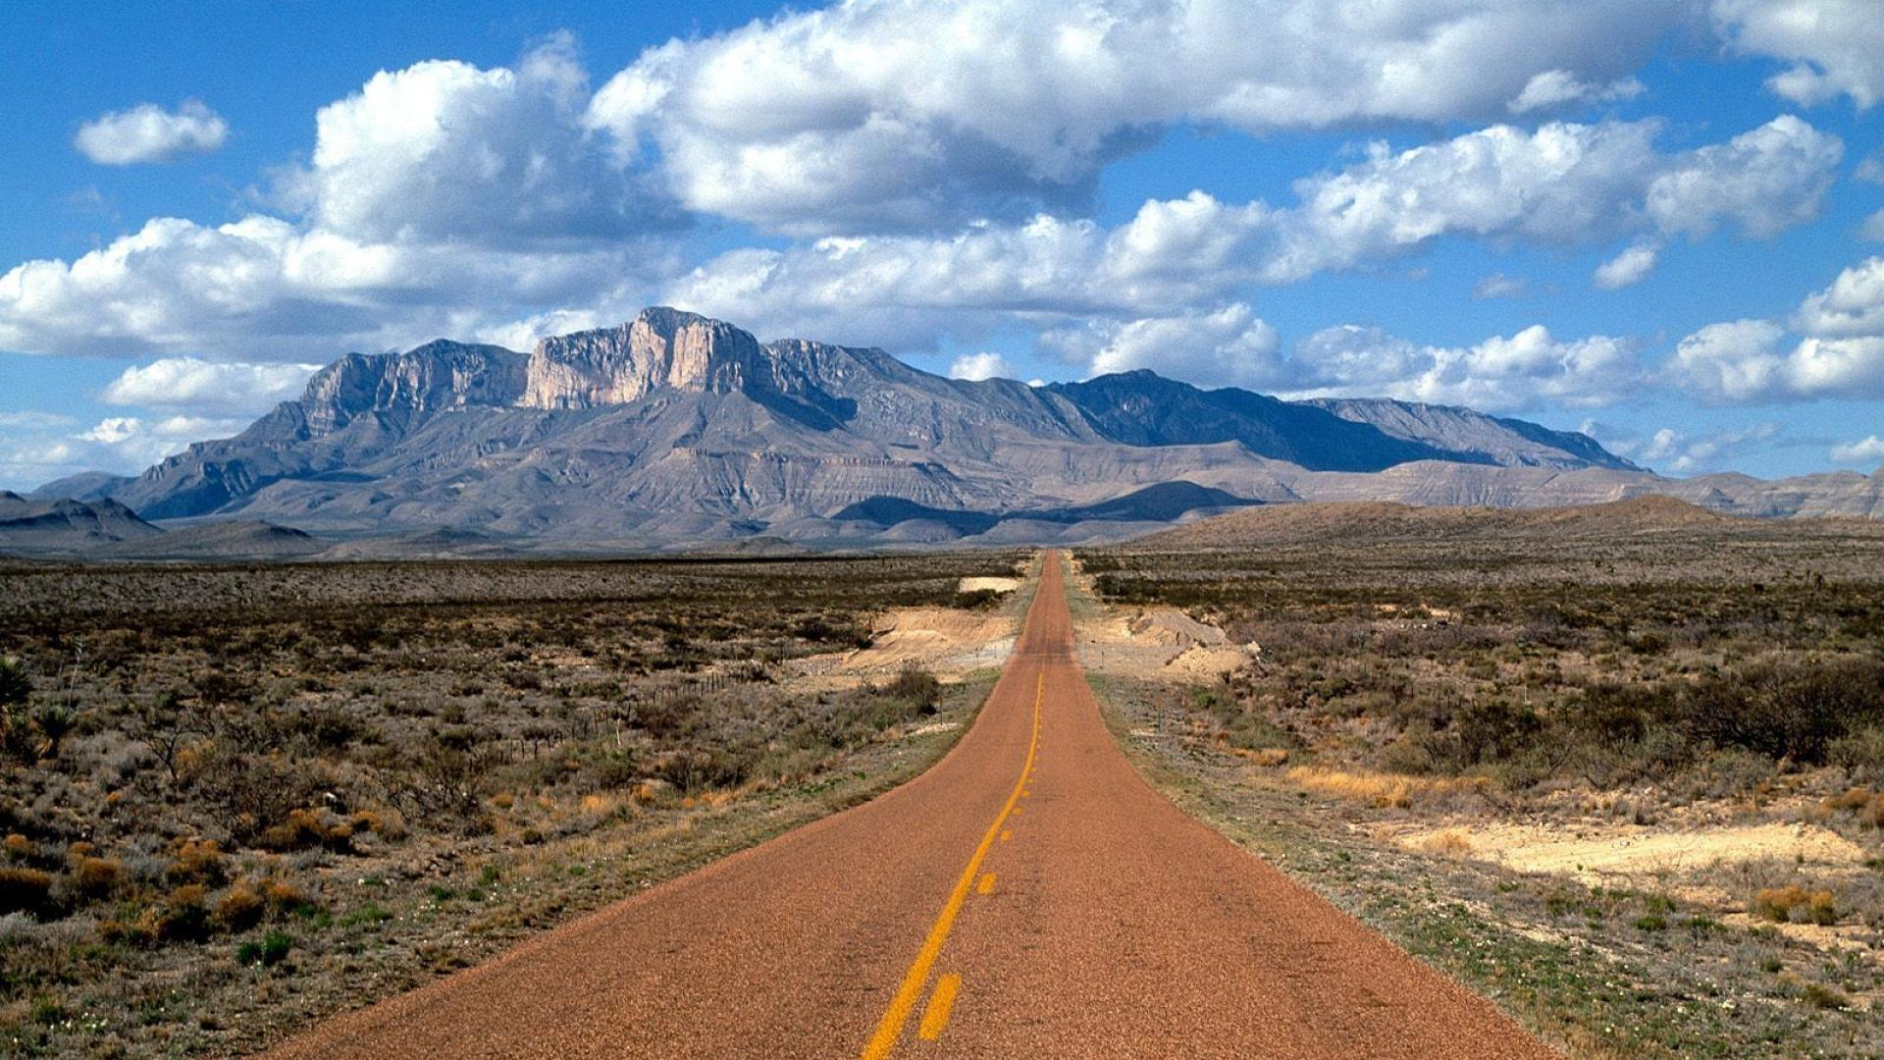

**Geography**

In geography, we will be investigating the geographical similarities and differences of a region of the United Kingdom and a region within North America, concentrating on key physical and human characteristics, countries, and major cities. We will use maps, atlases, globes and digital/computer mapping to locate countries and describe features studied.

mm 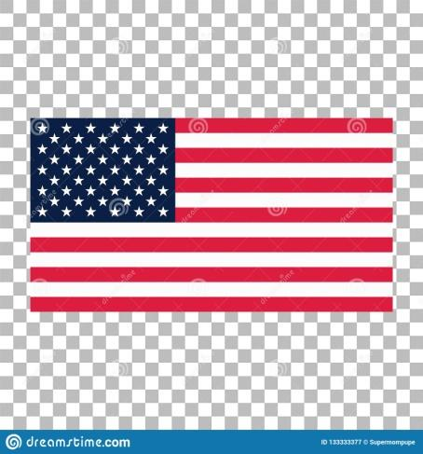

**Science**

During this half term, we will be studying **Living Things and their Habitats**. We will be classifying living things - including microorganisms, plants and animals - based on their observable characteristics and will be exploring the work of biologist Carl Linnaeus and the Linnaean classification system for all living things.

**Music**

We will continue our weekly music sessions with Mrs. Milner with a focus on composing and performing our own pieces as well as developing our understanding of musical notation.

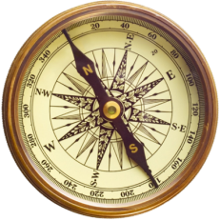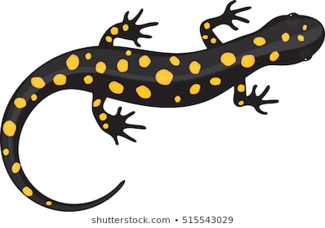 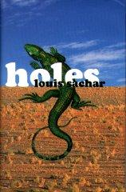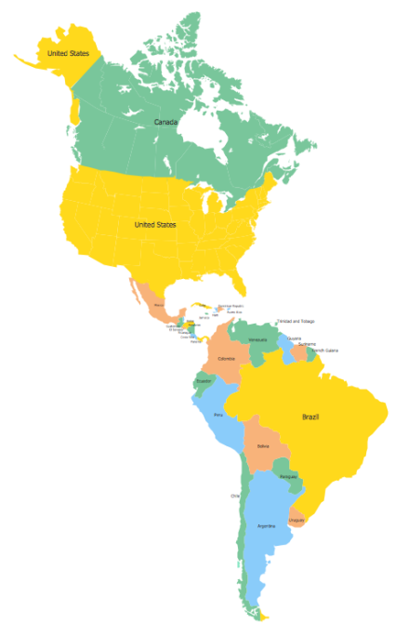

**Art**

This term, we will be exploring the work of Georgia O’Keefe’s American landscapes. We will design our own piece of work using O’Keefe as inspiration.

**Computing**

In our final computing units of the year, we will be using Purple Mash software to explore Spreadsheets, as well as understanding how to write and publish an effective blog.

**Maths**

This half term in maths we will be learning and consolidating our knowledge from place value to conversions through themed projects. We will also refine and explore written methods for all four mathematical operations x ÷ - + as well as practising our estimation and reasoning skills. We will be working with the children to ensure any areas they are less confident with is revisited.

**English**

Our final novel of the year is ‘Holes’ by Louis Sachar, which is set in Texas. We will be exploring the themes, plot, setting and characters during our English lessons and our spelling, punctuation and grammar objectives will be taught within the context of the story. We will continue to practise our reading strategies, and write our own character and setting descriptions, in addition to our own play scripts.

**RE & PSHCE**

In PSHCE, we will be thinking about physical and mental health, keeping safe, and Relationship and Sex education. In RE, we will be discussing the big question: What kind of King is Jesus?

**PE**

Year 6 will continue their weekly PE sessions with NUFC. They will be focussing on the necessary skills for a variety of athletics and will learn a range of dance movements.

**MFL**

In French this term we will continue to broaden our vocabulary and develop our ability to understand new words and phrases. We will be preparing for our residential trip, and certain children will be taking part in a French Vocabulary Bee.

**Amazing America Year 6 Curriculum Map - Summer Two**