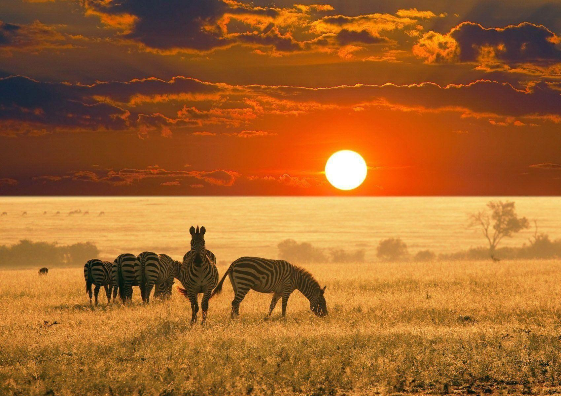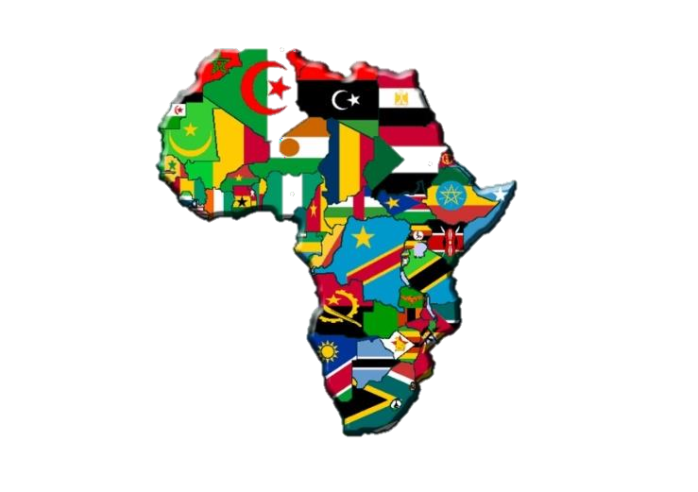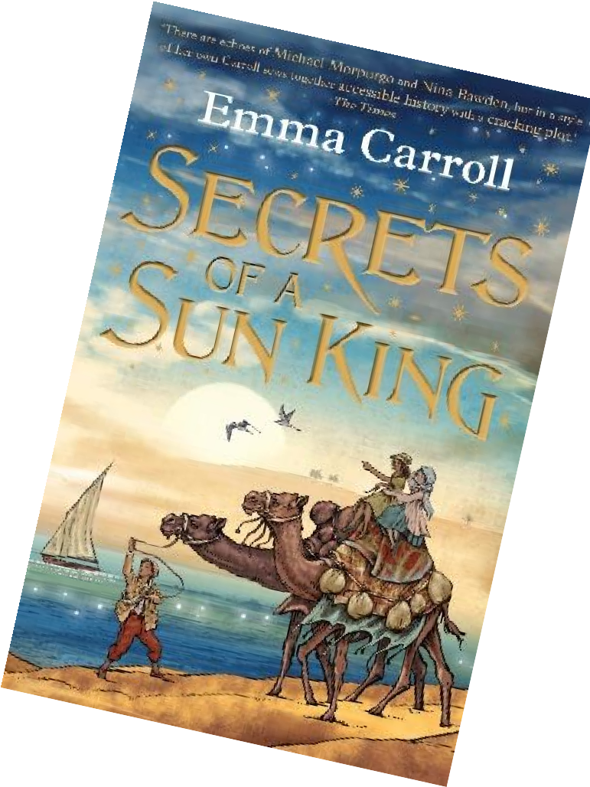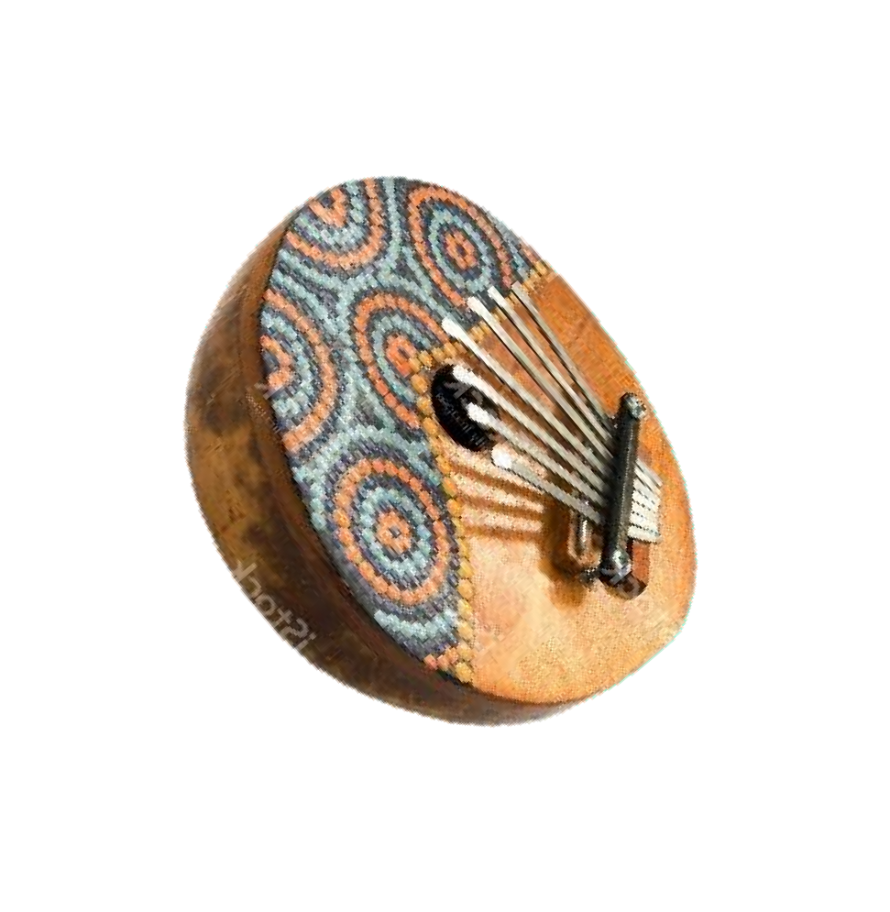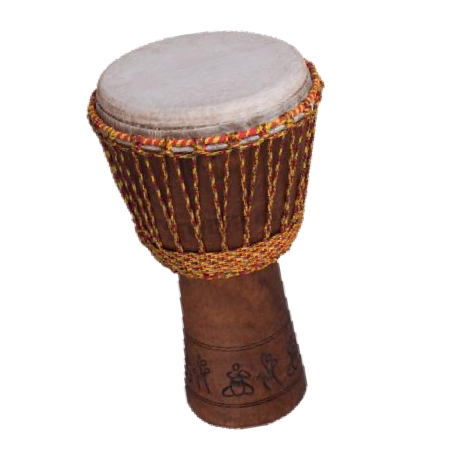

**Science**

During Summer term one, we will study Light. Pupils will explore the way that light behaves and investigate the relationship between light sources, objects and shadows. They will learn that light appears to travel in straight lines and that objects are seen because they give out or reflect light into the eye. Pupils will work scientifically by designing and making their very own periscope.

predictions.

**Computing This half term, the children will be exploring different types of quizzes such as sequencing, grouping and sorting, text based, multiple-choice and labeling. They will also continue to develop their understanding of how to use the Google Classroom programmes- in particular, spreadsheets.**

**DT & Music**

In DT this half term we will be

looking at ‘Frame Structures.’ We will look at how we can strengthen structures and how we can join materials together effectively.

In **music**, we will be rehearsing for our School Jubilee celebration at the end of the half term; it is beginning to sound rather incredible!

YEAR 6 CURRICULUM MAP SUMMER TERM ONE, 2023

**French**

The summer term provides an opportunity to revise all key vocabulary from KS2 French. We put this into practice by pretending to eat out and meet friends in the restaurants, ice cream parlours and crêperies of Paris!

**History & Geography**

We will conclude our Ancient Egyptian study before beginning to look at Egypt within the continent of Africa.

Pupils will learn to locate the countries of Africa, categorising them into different regions and exploring the human and physical features within countries studied. We will also study the different biomes and biodiversity within different regions, looking at indigenous flora and fauna as well as the equatorial climate.

**PE**

This term, we will be looking at ‘Athletics and Fitness’ with our NUFC coach each Thursday. Our second PE session will continue to take place on Tuesdays.

**Maths**

This term in maths we will be completing a unit angles: calculating missing angles on straight lines, full turns, quadrilaterals and triangles. We will also recap plotting coordinates in the four quadrants, in addition to translating and reflecting shapes. We will allow ourselves some revision time to recap basic skills in the run up to our KS2 SATs tests.

**RE & PSHE**

Our RE topic for Summer Term One will focus on Islam. We will explore what it means to be a Muslim in Britain today.

Our new PSHE unit is ‘physical health and mental wellbeing.’ We will be looking into what affects mental health and ways to take care of it.

**English**

Our work over the next term will continue to be based around the novel, **Secrets of a Sun King** by Emma Carroll. We will be exploring plot and character as well as generating our own Egyptian- inspired **creative writing**. During this **book study**, we will be deepening and developing various reading strategies such as questioning, prediction, **inference** and visualisation. Our spelling, punctuation and **grammar** objectives will be taught within the context of the book and our **non-fiction** work will complement our learning in geography lessons.