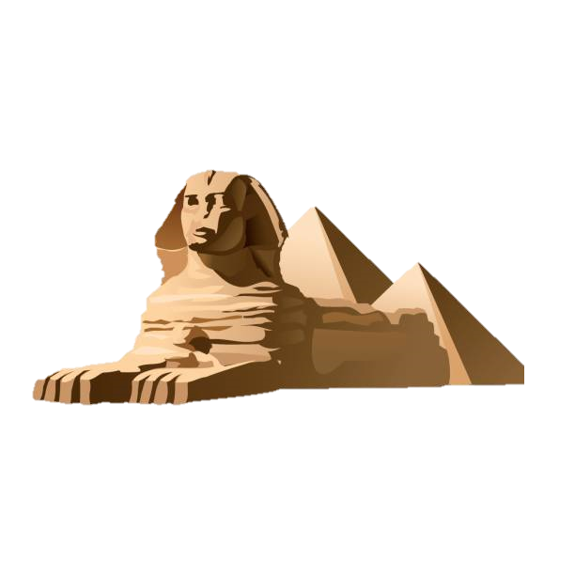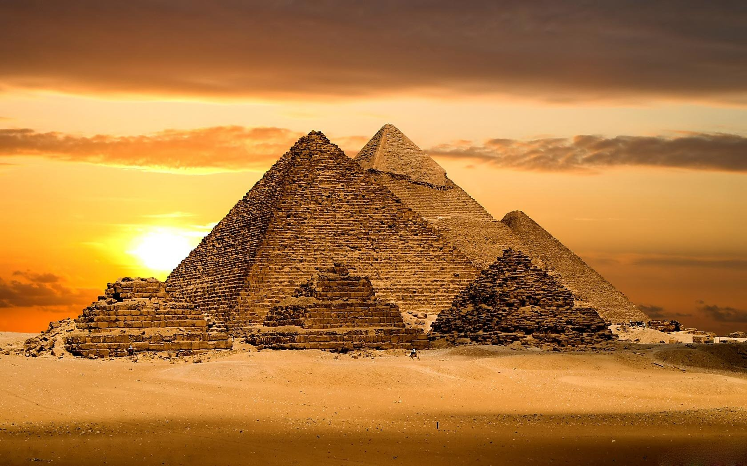

**Computing** This term, pupils will be discovering how to use spreadsheets, in order to complete computational modelling and problem solving in the ‘real world’. We will be using our mathematical skills to help us in this unit.

**History & Geography**

Pupils will develop a **chronologically** secure knowledge and understanding of the achievements of one of the earliest civilisations: The Ancient Egyptians. We will conduct an in-depth study of era, exploring Pharaohs, pyramids, Gods, daily life and the work of Egyptologists, such as Howard Carter. Our learning in history will be complemented in our English lessons.

**Science**

During this half term, pupils will be looking at diet and exercise and the impact their lifestyles can have on their bodies. Children will learn and discuss how drugs and other substances can be harmful to the human body. The children will also have the opportunity to explore the work of scientists and scientific research about the relationship between diet, exercise, drugs, lifestyle and health. Our Science learning objectives will be complemented in our PSHE lessons.

**Music**  In music, we will be learning about rhythm. In addition to this, we will be spending time rehearsing our medley for the up and coming 60th anniversary for the school. We can’t wait to share this with you!

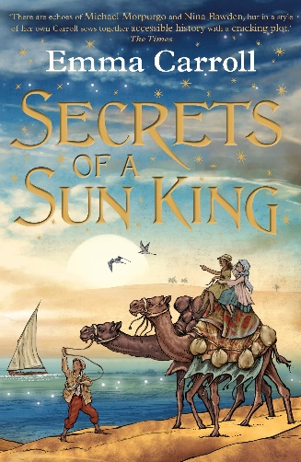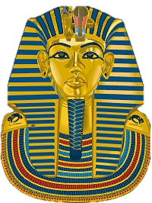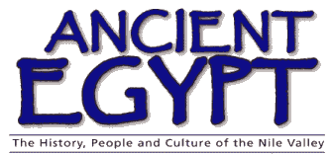

**French**

The introduction to etymology this half term (study of language origins) will assist in developing strategies for further language learning like Spanish and German at High School. We will identify and explore links between related languages and apply strategies for related language skills in translation.

**Art & DT**

Pupils will design and create an alarm system for the British Museum, using their knowledge of electrical circuits from previous science units. We will extend this project into the summer term.

**RE & PSHE**

Our RE topic for this term is SALVATION - we will be exploring what difference the resurrection makes for Christians.

In PSHE, we will be exploring a balanced lifestyle and what it means to have a healthy body and mind.

**PE**

We will continue our sessions with the NUFC foundation, focussing on attacking and defending invasion games. On our Tuesday PE sessions we will explore the rules and skills used within Cricket.

**Maths**

This term in maths we will be completing a unit of work on area, perimeter and volume, in addition to a unit on statistics. We will be revisiting our arithmetic strategies used across the year in preparation for the Key Stage 2 SATs exams taking place in the summer term.

**English**

Our work over the next term will centre around the novel, **Secrets of a Sun King** by Emma Carroll. We will be exploring plot and character as well as generating our own Egyptian-inspired **creative writing**. During this **book study**, we will be deepening and developing various reading strategies such as questioning, prediction, **inference** and visualisation. Our spelling, punctuation and **grammar** objectives will be taught within the context of the book and our **non-fiction** work will complement our learning in history lessons.

*YEAR 6 CURRICULUM MAP SPRING TERM 2, 2023*