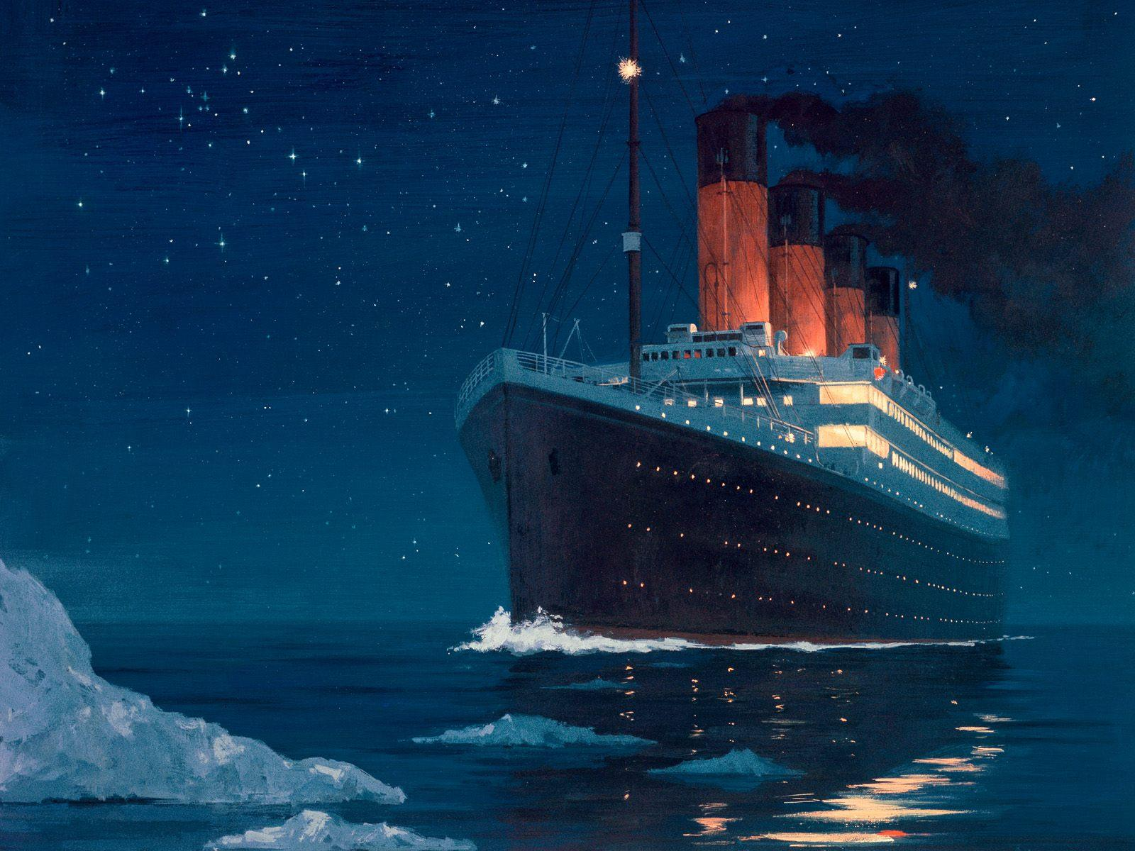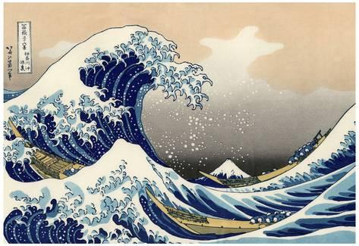

**Music:**

In music, we will be exploring metre. Metre refers to the regularly recurring patterns and accents such as bars and beats. We will also begin to rehearse for our next Church Services.

**Art & DT**

**‘The Great Wave of Kanagawa’** --Hokusai Study. Children will explore the work of Hokusai and use this to inspire their own wave-based artwork. We will also be learning how to create structured patterns using the Zentangle method, which we will utilise in our final art piece.

**Science**

This half term we will be studying the circulatory system. We will be able to identify and name the main parts of this system, and describe the function of the heart, blood vessels and blood. We will learn about the composition of blood and the important role that blood cells, platelets and plasma play in keeping our bodies functioning. We will also learn about how water and nutrients are transported around our body.

**Computing:**

Using coding software, we will design and make programmes that include timers and scores.

**Geography**

This half term, we will learn to describe and understand key aspects of Physical Geography; including **volcanoes and earthquakes**, looking at plate **tectonics** and the **ring of fire**. We will locate and explore areas of the earth that experience extreme **weather** conditions, and discuss the implications that this may have on their populations. We will also look at the historical voyage of the Titanic.

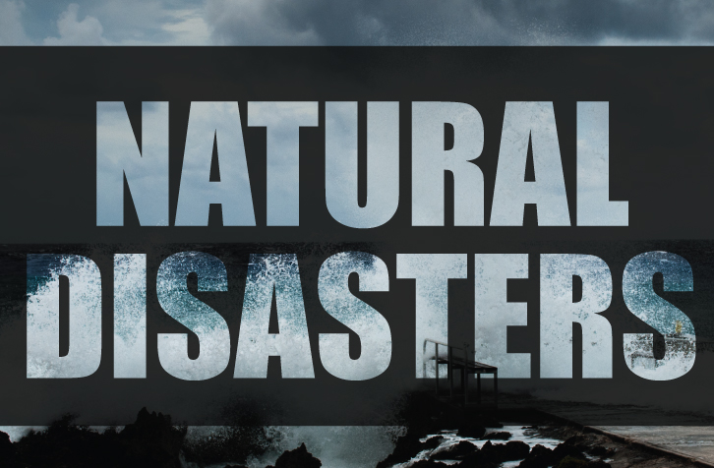

**&**

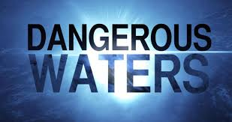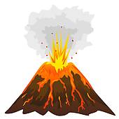

**Year Six - Spring Term One**

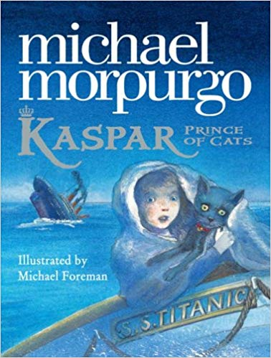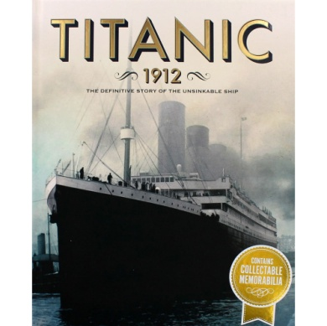

**RE & PSHCE**

In RE we will be studying Islam; specifically focusing upon the five Pillars of Islam that all Muslims follow. Our PSHCE this half term is all about **respect**.: respecting differences, respect in relationships and the mutuality between respect and power.

**English**

Our new class novel this half term is the historic-fictional tale, *Kaspar Prince of Cats* (AKA *Kaspar the Titanic Cat*) by Michael Morpurgo. We will use this text to guide our reading, writing and grammar lessons. Across the half term we will be writing an information booklet based upon the Titanic, a diary entry from the perspective of the protagonist, a setting description, and a discursive argument where we consider who was responsible for the sinking of the vessel. Our weekly spelling work will continue to be set on Mondays, and is due in by Friday.

**PE:** Our PE will continue with the NUFC foundation. Our focus this half term is **attacking and defending** in a range of games.

**French**

What do you like to do? In French lessons this half term, we talk about our favourite things, hobbies, and how we are feeling.

**Maths**

Our maths begins by looking at ratio. We will be introduced to the ratio symbol, before exploring the relationship between ratio and fractions. We will use this knowledge to solve problems involving proportions. We will then move onto solving algebraic equations, before finishing the half term with a recap of decimals. Our decimals unit will have a particular focus on place value and the four operations.