This half of Spring term in Year 2 we will be learning...
DT
This half term we will focus on DT and making a moving vehicle. Children will investigate different mechanisms and develop some cutting, joining and finishing skills. They will plan, make and review their model.

Maths
Children will continue to develop their skills in number and calculations. This half term the children will learn multiplication and division and understand strategies to solve these calculations. Daily, children will continue to develop their number fluency through mastering number sessions.
English
Literature Works or Read Write Inc will be taught daily incorporating whole-class guided reading sessions as well as children being heard to read individually. They will focus on fiction writing, exploring characters, setting and story structure. We will be learning to use varied sentence openers, conjunctions, adjectives and similes in order to develop writing style. Children will also become familiar with non-fiction texts relating to our Castles topic.

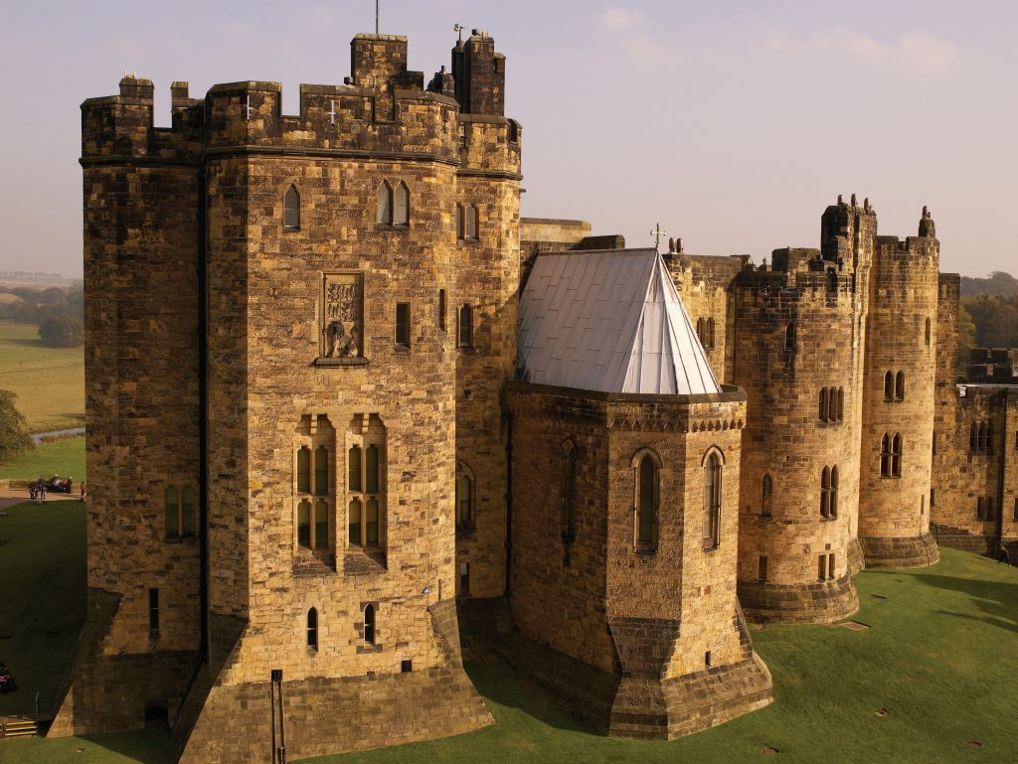

Castles!

Computing
In Computing, children will learn about spreadsheets. During this unit of work they will review the use of spreadsheets and use their own to add amounts and then create a table and block graph to show results.

Geography
This half term we will focus on Geography. We will look at the United Kingdom and use geographical vocabulary to describe the features of where castles are located and the features of the castle themselves. We will also develop map skills, reading, looking at symbols and drawing maps.

R.E & PSHCE
In R.E children will go deeper in their learning about the Gospel and be discussing what the good news is, that Jesus brings.
In PSHCE we will be looking at belonging to a community and similarities and differences of others within the group. We will also learn about media literacy and digital resilience.

Science
In science, we will be studying everyday materials including identifying materials, investigating their suitability for different roles and understanding how we can change their shape.
Music
This half term we are going to listen to a range of different kinds of music from the past. We will continue to have our Music lessons from Mrs Milner, focussing on pitch, rhythm and tempo.

P.E
This half term we will focus on gymnastics, children will practise and develop their skills of balancing, rolling, jumping and creating routines. Children will continue to have a session taught by NUFC during the week.

S
Year 2 - Spring Term 1 2023

Additional Information:
Reading: Please hear your child read/read with your child every day and record this in their yellow reading diary - remember, your child is entered into the Reading Raffle each time they have their reading recorded in their diary.
P.E:
There are two P.E. sessions per week. Your child should continue to dress appropriately for PE on their allocated PE days. PE uniform should consist of black/blue jogging bottoms, white t-shirt and school jumper as well as trainers.

Water Bottles and snacks:
Please continue to send your child to school each day with a named water bottle.
At morning break time children can have a healthy snack such as a piece of fruit or vegetable, which should be brought in from home.

Mrs Southern & Mrs Abbott

