This half Term, Year 2 will be learning…



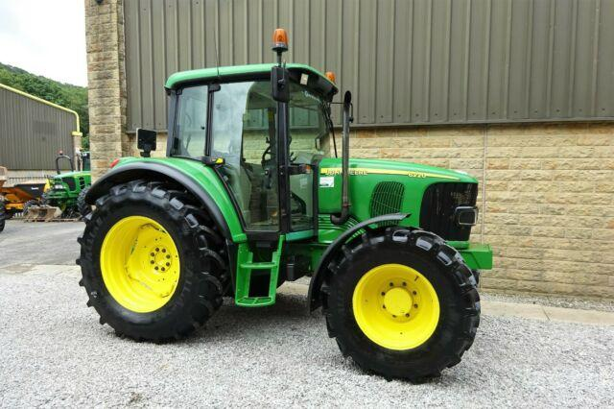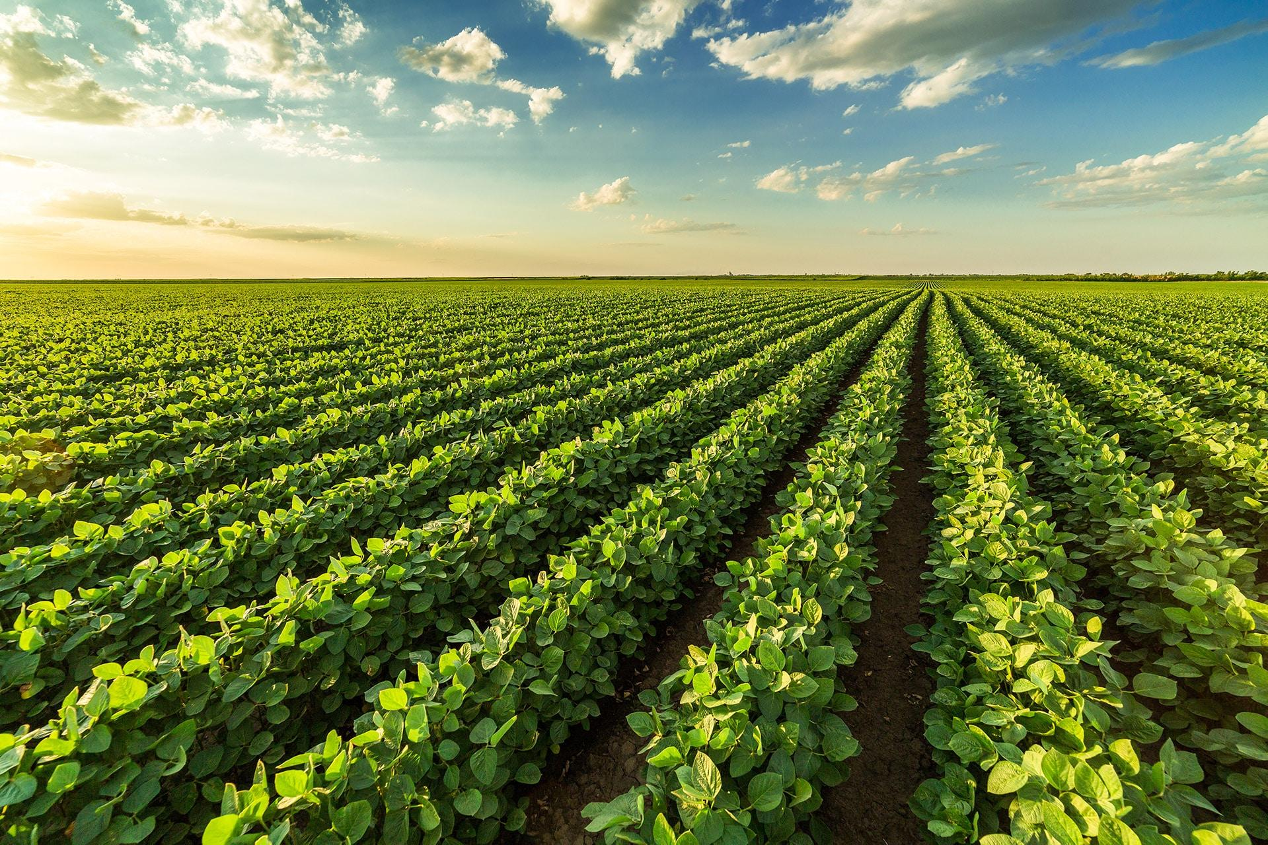

Food and Farming

Autumn 1 2022