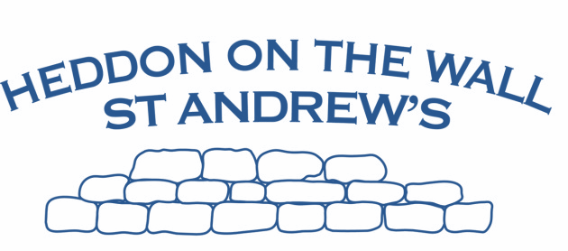

Week one | Week two | Week three | Week four | Week five | Week six
Revision – spellings we have learned in Year 3. | Revision – spellings we have learned in Year 3. | Castle specific words- Made in the North East project. | Revision – spellings we have learned in Year 3. | Revision – spellings we have learned in Year 3. | Revision – spellings we have learned in Year 3.
treasure | pleasure | dungeon | teacher | disappear | freight
furniture | island | portcullis | scheme | reaction | hourly
answer | dislocate | ramparts | history | capable | missed
refresh | disadvantage | turret | mention | personal | suppose
dislodge | decide | Northumberland | bawl | specifically | plaque
mislead | survey | defence | crescent | misunderstanding | descend
gardener | exactly | battlements | eighteen | freight | grotesque
focussing | bravely | gatehouse | regular | committed | automatically
regular | ordinary | Alnwick | disable | forbidden | daily
sleigh | promise | armour | mane | neighbour | scented

Year 3 Spellings Term: Summer two 10 words per week Test: Friday

