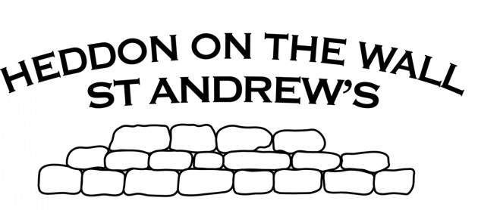
Week one | Week two | Week three | Week four | Week five | Week six | Week seven
The /ow/ sound spelled ‘ou.’ Found often in the middle of words, sometimes at the beginning and very rarely at the end of words. | The /u/ sound spelled ‘ou.’ This digraph is only found in the middle of words. | Spelling Rule: The /i/ sound spelled with a ‘y.’ | Words with endings that sound like /ze/ as in measure are always spelled with ‘-sure.’ | Words with endings that sound like /ch/ is often spelled –’ture’ unless the root word ends in (t)ch. | Challenge words | Words with the prefix ’re-’ where ‘re-’ means ‘again’ or ‘back.’
Mouth | Touch | Gym | Measure | Creature | Actual | Redo
Around | Double | Myth | Treasure | Furniture | Answer | Refresh
Sprout | Country | Egypt | Pleasure | Picture | Bicycle | Return
Sound | Trouble | Pyramid | Enclosure | Nature | Circle | Reappear
Spout | Young | Mystery | Displeasure | Adventure | Earth | Redecorate
Ouch | Cousin | Symbol | Composure | Capture | Enough | Revenge
Hound | Enough | Synonym | Leisure | Future | Fruit | Review
Trout | Encourage | Lyrics | Exposure | Sculpture | Island | Replay
Found | Flourish | System | Closure | Fracture | Often | Reaction
Proud | Couple | Gymnastics | Disclosure | Mixture | Popular | Rebound
Year 3 Spellings Term: Autumn one 10 words per week Test: Friday

Words in blue are taken from the National Curriculum Spelling List for Years 3 and 4.

