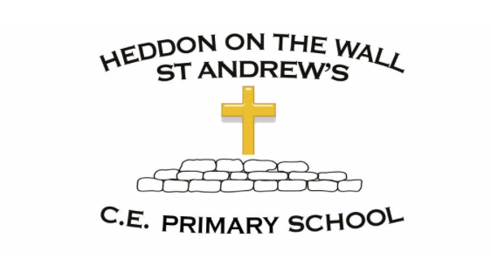
Year 3 – Summer 2 – Spellings

Week 1  WB- 07/06/21  Statutory Word List Assessment | Week 2  WB- 14/06/21  Homophones | Week 3  WB- 21/06/21  The short i sound spelt y | Week 4  WB- 28/06/21  High frequency words | Week 5  WB- 05/07/21  High frequency words | Week 6  WB- 12/07/21  High frequency words
accident  believe  calendar  caught  circle  difficult  eighth  favourite  fruit  knowledge | bear  bare  brake  break  here  hear  knew  new  difficult  ordinary | Egypt  pyramid  gym  mystery  syllable  earth  height  heard  forward  circle | after  again  any  around  because  better  knowledge  medicine  minute  opposite | people  clothes  every  everyone  how  peculiar  caught  accident  quarter  fruit | who  people  with  think  little  potatoes  remember  sentence  separate  favourite

