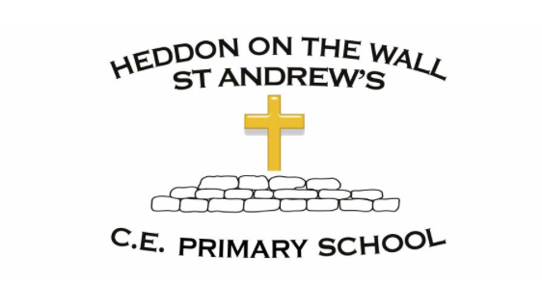
Year 3 – Summer 2 – Spellings

Week 1  WB- 07/06/21  Statutory Word List Assessment | Week 2  WB- 14/06/21  Homophones | Week 3  WB- 21/06/21  The short i sound spelt y | Week 4  WB- 28/06/21  Adding the prefix re- | Week 5  WB- 05/07/21  Adding the prefix anti- | Week 6  WB- 12/07/21  Adding the prefix super-
accident  believe  calendar  caught  circle  difficult  eighth  favourite  fruit  knowledge | bear  bare  brake  break  here  hear  knew  new  difficult  ordinary | Egypt  pyramid  gym  mystery  syllable  earth  height  heard  forward  circle | rearrange  reappear  redecorate  recycle  replay  reheat  knowledge  medicine  minute  opposite | anticlockwise  antiseptic  antifreeze  antisocial  antidote  peculiar  caught  accident  quarter  fruit | superhero  supermarket  superhuman  superstar  superfast  potatoes  remember  sentence  separate  favourite

