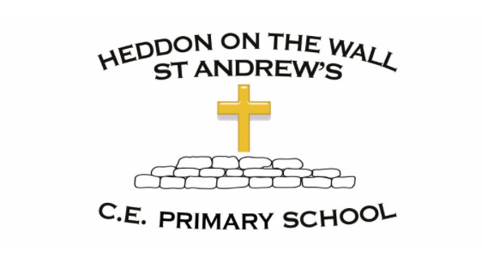
Year 3 – Summer 1 – Spellings

Week 1  WB- 12/04/21  The suffix ‘ture’ | Week 2  WB- 19/04/21  Homophones | Week 3  WB- 26/04/21  Adding –ation to verbs to form nouns | Week 4  WB- 03/05/21  Words with the c sound spelt ch | Week 5  WB- 10/05/21  Words with the sh sound spelt ch | Week 6  WB- 17/05/21  Adding the suffix –ion | Week 7  WB- 24/05/21  Adding the suffix –ian
adventure  mixture  fixture  picture  furniture  capture  caught  certain  decide  describe | wear  where  brake  break  here  hear  knew  new  different  disappear | prepare -> preparation  admire -> admiration  animate -> animation  operate -> operation  decorate -> decoration  earth  height  heard  forward  library | chemist  character  chemical  stomach  echo  scheme  knowledge  medicine  minute  opposite | chef  charade  brochure  machine  parachute  quiche  peculiar  popular  promise  quarter | action  collection  invention  injection  confusion  infection  potatoes  remember  sentence  separate | musician  politician  politician  mathematician  electrician  librarian  therefore  various  different  library

