**This Spring term in Year 2 we will be learning... l**



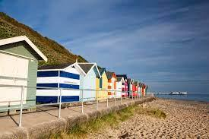

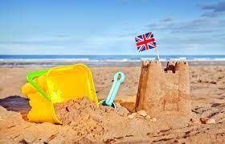



**S**



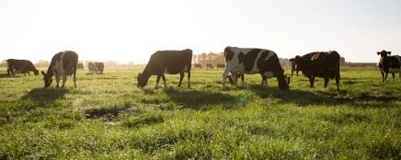

**Additional Information:**

**Reading:**

Please hear your child read/read with your child every day, either from a school reading book, or a book from home. Please ensure that you record when you have read with your child in their homework diary. Children should have their reading books with them daily so we can listen to them read throughout the week. Books will be changed when required. Library books must be returned on Friday for a new one to be issued.

**Spellings:**

Your child will bring home new words to learn. They will be tested every Friday. Please help them to practise their spellings.

**Homework:**

Weekly homework will consist of reading and spelling.

Topic homework will consist of a ‘Homework Bingo’ and will be due by the end of the Summer 1 half-term.

**P.E:**

There are two P.E. sessions per week on Tuesday and Wednesday. Your child should continue to dress appropriately for PE on their allocated PE days. PE uniform should conist of black/blue jogging bottoms/shorts, white t-shirt and school jumper as well as trainers.

On Thursday, the children in Year 2 will continue their project of developing the wildlife area and should bring wellies.

**Water Bottles and snacks:**

Please continue to send your child to school each day with a named water bottle.

At morning break time children can have a healthy snack such as piece of fruit or vegetables, which should be brought in from home**.**

Finally, if you have any concerns or questions regarding your child, please do not hesitate to contact us by email or by phoning school.

year2home@heddon-school.co.uk

Mrs Southern and Mrs Abbott