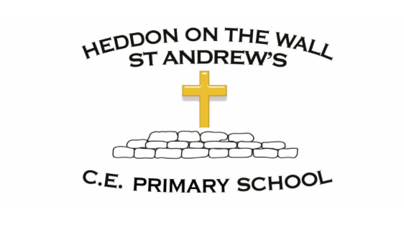
Year 3 – Spring 2 – Spellings

Week 1  WB- 22/02/21  The prefixes ‘dis’ and ‘in’ | Week 2  WB- 01/03/21  Homophones | Week 3  WB- 08/03/21  The suffix ‘ous’ | Week 4  WB- 15/03/21  The suffix ‘ly’ | Week 5  WB- 22/03/21  Statutory word list assessment
incomplete  invisible  incapable  independent  dishonest  disapprove  disagree  accident  accidentally  arrive | blue  blew  hear  here  knight  night  believe  address  appear  answer | delicious  dangerous  enormous  curious  famous  jealous  bicycle  calendar  enough  island | horribly  gently  carefully  humbly  simply  quietly  unfriendly  breath  breathe  length | believe  address  appear  answer  breathe  bicycle  calendar  accidentally  enough  island

