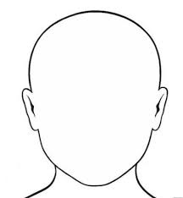**How I’m feeling about going back to school!**

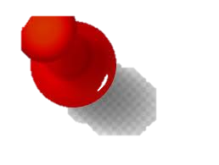3 Things I’m excited about…

*

*

*

**This is how I’m feeling right now!**

****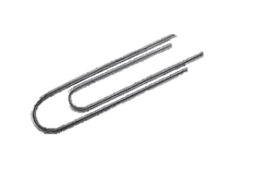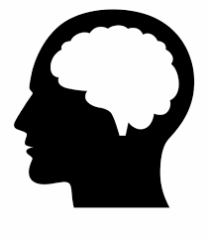

1.

2.

3.

I found the following difficult

during lockdown…

**This is what is on my mind at the moment!**

3 things I have achieved in lockdown …