Life in Tudor Times

Over 500 years ago, life in England was very different. The Tudor reign was from 1485 to 1603. The Tudors were a Welsh family who ruled England and Wales during this exciting time. There were 6 different Monarchs within the Tudor times but King Henry VIII and Elizabeth I are the most famous.

Life in Tudor times
Life in Tudor Britain was harsh - the average life expectancy was just 35 years. Tudor England was a farming society. Most of the population (over 90 %) lived in small villages and made their living from farming.
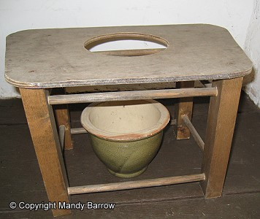
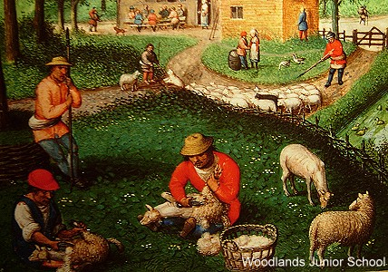
A privy was the toilet.

A farm in Tudor times

There were none of the comforts we have today. Water was collected from village pumps, wells or streams but was often polluted. Toilets were called 'Privies' and were not very private at all. They were often just a piece of wood over a bowl or a hole in the ground. People would wipe their bottoms with leaves or moss and the wealthier people used soft lamb's wool.

The Rich
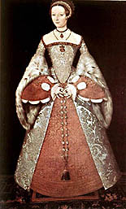
Wealthy Tudors loved to show of their riches. The clothes they wore and the homes they lived in were all signs of their place in society. Food was another show of wealth. The rich could afford all kinds of meats and fish and expensive French wine. The best food was considered to be roast veal and venison.
People also ate robins, badgers, otters, tortoises and seagulls.
Beautiful dresses and rich materials were a sign of wealth.

The Poor
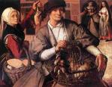
The poor had to work hard and struggled to survive. They worked six days a week and only had holy days and public holidays off work. They ate coarse grey bread made from rye and barley. Soups were made from vegetables and herbs. Meat was a luxury but poor people sometimes kept animals to provide milk, cheese and eggs. Life for the poor in Tudor times was harsh. When the harvest failed it was tempting for poor people to steal food. When people did break the law, they risked public flogging or being hanged.

Tudor schools
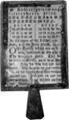
Not many children went to school in Tudor times. Those that did go were mainly the sons of wealthy or working families who could afford to pay the attendance fee. Boys began school at the age of 4 and moved to grammar school when they were 7. Girls were either kept at home by their parents to help with housework or sent out to work to bring money in for the family. Boys were educated for work and the girls for marriage and running a household. The wealthiest families hired a tutor to teach the boys at home. Many Tudor towns and villages had a parish school where the local vicar taught boys to read and write.
Tudor children used hornbooks to learn to read.

During 118 years of Tudor rule, England became richer than ever before. As the country became wealthier, towns grew, beautiful houses were built and schools and colleges were set up. Arts and crafts flourished too. England was home to great painters, writers and musicians.

privy | A group of people living close by or work together. They often have common interests or beliefs.
wealth | A King or Queen who rules the area.
population | A toilet located in a small shed or other shelter outside the house.
society | Shaped like a paddle and made out of wood or sometimes bone, this was used for children at school to help them read and write.
flogged | The number of people who are alive in one place.
monarch | To be beaten with a rod/stick or whip.
venison | Lots of valuable possessions or money.
hornbook | Meat from a deer.
Match the words to their meaning.

Before you stick them in, arrange them into alphabetical order.

