Google Classroom!

I am very excited to start using Google classroom with you all.
To begin with, I will be using it to upload videos for you all… including our new Wake Up Shake up!

So… to start, you will need to go into google. In the top right corner, you will see Log in, or perhaps a letter in a circle. Click on this and you either need to login or use a new account.

Now log in with your school gmail
account. This will be
3133 followed by the first letter of your first name
and then your surname.
The type @heddon-school.co.uk

Your password is your first name, with a capital letter.

Now go to the 9 dots at the top right of the google page and click that so that you get a menu.
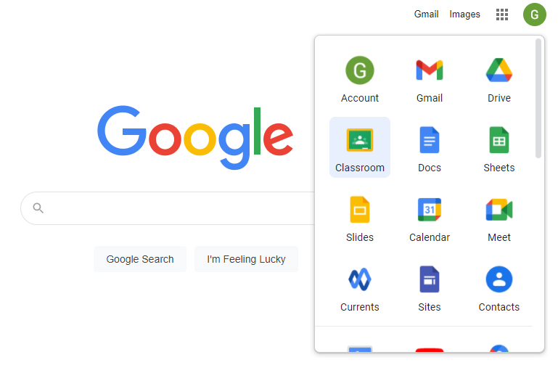
Find Google Classroom icon and click.

You might need to click continue and then select you are a student.
You should then be taken to this page
Click on here to enter our Year 2 google classroom.
I will be putting some videos on today to try it out. The first one is ‘Have you filled your bucket?’
See if you can find it.

Please let me know how you get on. I’m going to put the Wake Up Shake Up video on as well!

ENJOY!

Mrs Southern

