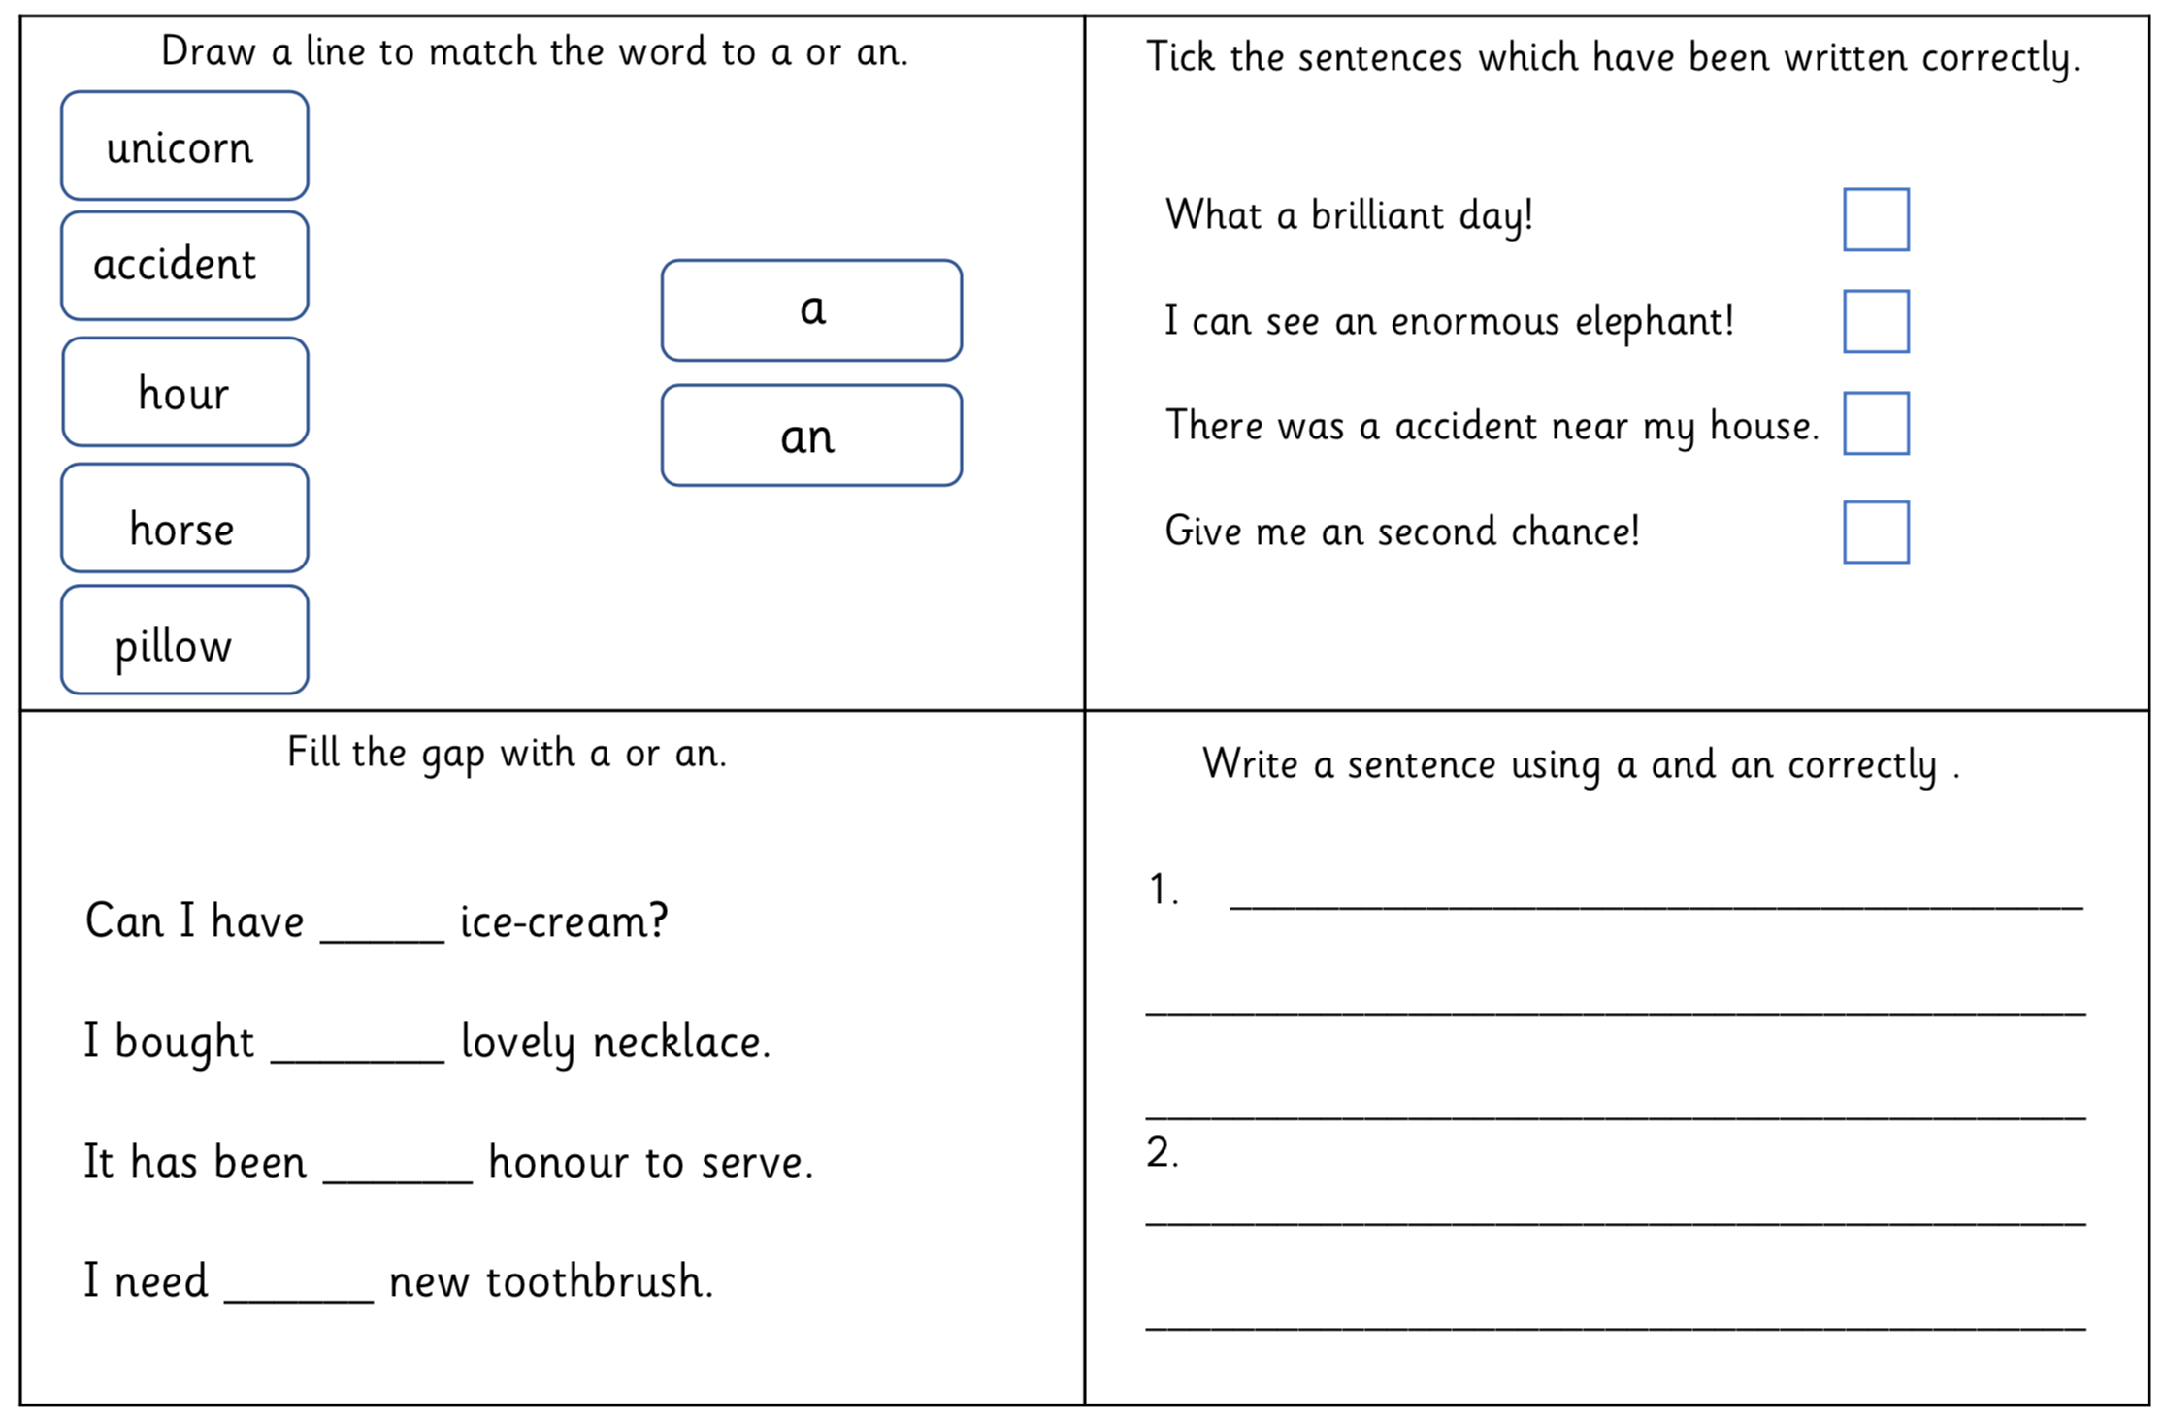
Once, in an house on Egypt Street, there lived an rabbit who was made almost entirely of china. He had china arms and china legs, china paws and a china head, an china torso and a china nose. His arms and legs were jointed and joined by wire so that his china elbows and china knees could be bent, giving him much freedom of movement.
His ears were made of real rabbit fur, and beneath the fur, there were strong, bendable wires, which allowed the ears to be arranged into poses that reflected the rabbit’s mood. His tail, too, was made of real rabbit fur and was fluffy and soft and well shaped.
The rabbit’s name was Edward Tulane, and he was tall. He measured almost three feet from the tip of his ears to the tip of his feet; his eyes were painted an penetrating and intelligent blue. He wore an fine silk suit, which was a amazing colour.

