**Here are some examples of the pneumatic monsters some of us created. You all did a brilliant job!!**

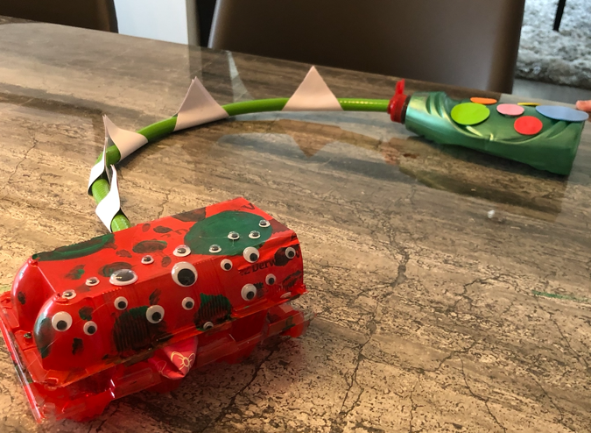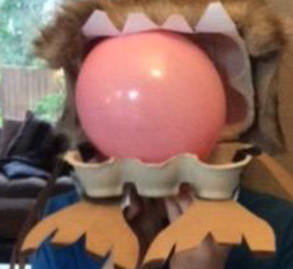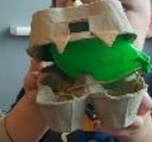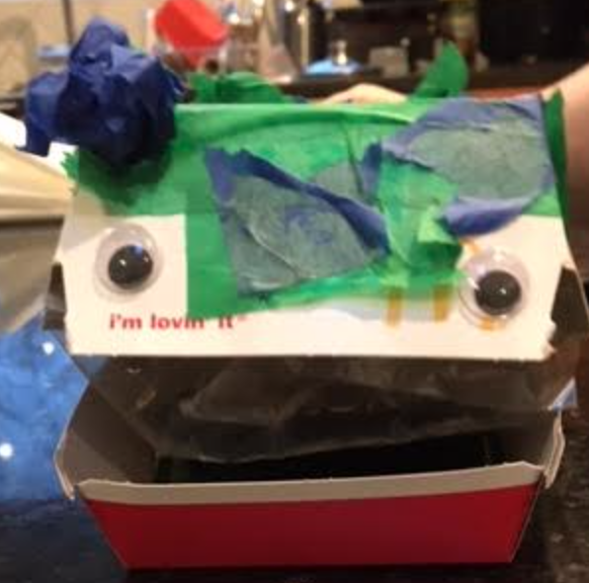

Your job is to now evaluate your monster. If you were not able to make one, choose one above to evaluate. Use the worksheets below to do this.

