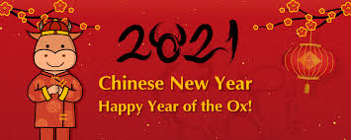
Chinese New Year!

Chinese New Year, also known as the Spring Festival, is the main Chinese festival of the year. As the Chinese use the lunar calendar for their festivals the date of Chinese New Year changes from year to year. The date corresponds to the new moon (black moon) in either late January or February. The spring festival celebrates the start of new life and the season of ploughing and sowing. This year, Chinese New Year is on Friday 12th February 2021.
Traditionally, celebrations last for fifteen days, ending on the date of the full moon, when it is at its brightest. The first week is celebrated with visits to friends and family following special traditions designed to bring good luck. The second week ends with the Lantern Festival on the evening of the 15th day of the lunar month.
In China, the public holiday lasts for three days and this is the biggest and most extravagant celebration of the year.
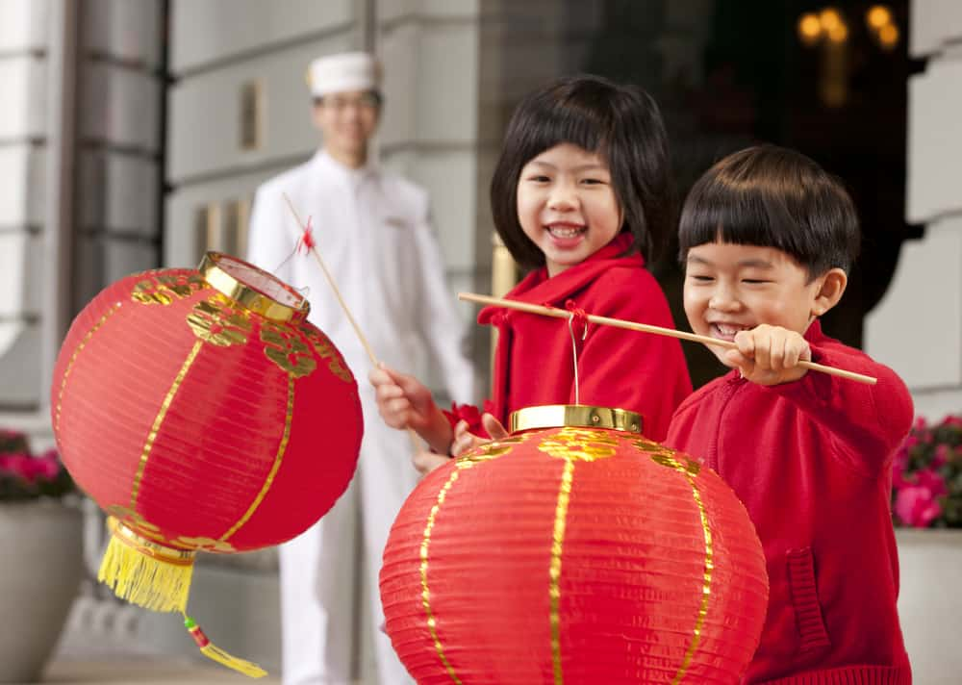
The Chinese calendar is different from that used in the United Kingdom. It is made up of a cycle of twelve years, each of them being named after an animal. This is very like our signs of the zodiac or star signs. Some people believe that people born in a particular year, such as the Year of the Dog, will have some of the characteristics of that animal.

Top Ten Facts:
- Before the start of the festivities, Chinese people spring clean their houses to sweep away any bad luck.
- On New Year's Eve, all brooms, dustpan and brushes are put away so that good luck can’t be swept away. Houses are decorated with paper scrolls with good luck phrases such as 'Happiness' and 'Wealth'.
- People will stay up until midnight setting off fireworks to frighten away evil spirits. Red symbolises fire which will scare away evil spirits, so people dress head to foot in new red clothing.
- Children receive red envelopes full of money instead of wrapped gifts that other nationalities give at Christmas. The amount they receive is usually an even number but the amount cannot be divisible by four. In Chinese, the number 4 means death!
- Everyone goes home for the Chinese New Year celebrations, if they can. The period just before the Chinese New Year, called ‘chunyun’, is the busiest travel time of the entire year. All across China and beyond, you’ll find people on their way home to spend this time with their families.
- Lion and dragon dances are common during the Chinese New Year and it is believed that the loud drumming and clashing of cymbals will chase away bad luck and evil spirits.
- Some Chinese believe you should not wash your hair on the first day of the Chinese New Year as you would be washing away your good luck for the New Year.
- Chinese believe that all outstanding bills and monies owed to friends and family members should be paid off before the Chinese New Year.
- The Chinese believe that crying and wailing on the first day of the Chinese New Year will result in sad times for the remainder of the year. It is also frowned upon to start the New Year by getting upset or getting angry.
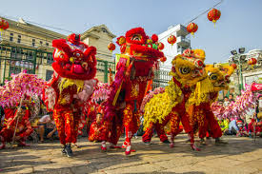
- White or black clothing are often avoided during the festivities as they represent the traditional colours of mourning for Chinese.

Food
Food is also very important to New Year's celebrations. Families and friends get together for large feasts. Before they eat, they place their food on alters and make offerings to the gods. The foods served at these feasts vary, but what is served is always a tradition for that family. According to the Chinese New Year facts, each of the food items represents a symbol of luck:
- Bamboo shoots, egg rolls, oranges or seaweed: wealth
- Chicken: happiness and marriage
- Dried bean curd: happiness
- Eggs: fertility
- Fish served whole: prosperity
- Chinese garlic chives: everlasting, a long life
- Lychee nuts: close family ties
- Noodles or peanuts: a long life
- Seeds: having a large number of children
- Tangerines: luck
