Chinese New Year Lanterns

Chinese New Year Lanterns make great decorations and this time of the year, you see them popping up everywhere around town, the temples, the stores, homes, parks...

Chinese lanterns come in all sorts of shapes, sizes and colors, although for Chinese New Year, the traditional red and gold balloon lantern is one of the most popular ones.

Follow the instructions below. All you need is some paper and glue and a few other things you are likely to have at home to make this bright and cheery lantern and get in the holiday spirit!

Make a Chinese New Year Lantern
There are only a few easy steps to these beautiful Chinese New Year paper lanterns:

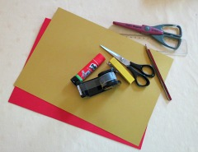
Materials needed:
- One sheet red paper
- Two to three sheets gold paper
- Pencil and ruler
- Regular Scissors
- Scissors with fun shape (optional)
- Glue
- Tape
- Stapler

Step 1:
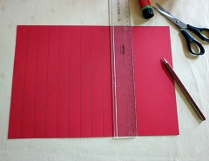
- Use the pencil and ruler to trace lines about 3/4" apart perpendicular and along the whole length of the red paper

Step 2:
- Use the scissors to cut through the lines leaving approximately 1/2" at the top uncut
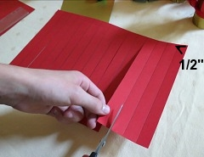
- This will form the bars that will form the balloon of the lantern.

Step 3:
- Use some tape to hold the bottom of the bars together
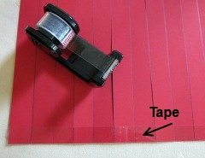

Step 4:
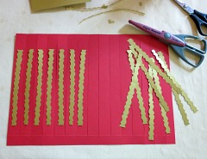
- Using the fun-shape scissor, or the regular scissors if you don't have one, cut thin stripes of gold paper
- Glue the trimmings to the lantern bars

Step 5:
- Fold 1/2" at the top and bottom of the red paper
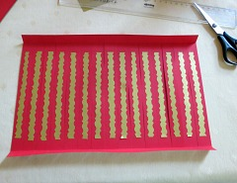
- You can use the ruler and scissors to make a light crease so it folds easily

Step 6:
- Take a gold sheet of paper
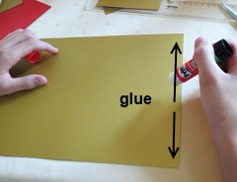
- Apply glue to one of the sides

Step 7:
- Roll the gold paper to form a tube, this will be the center of the lantern
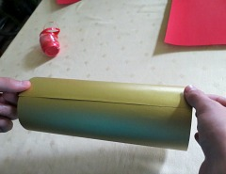
- Secure the ends with the glue

Step 8:
- Roll the red paper over the gold tube
- Match only one side of the red paper to one end of the gold tube and glue them together
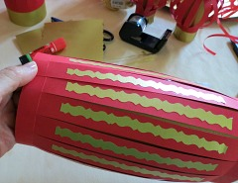
- You can secure it with a couple of staples just to make sure it won't come off, the other side stays loose

Step 9:
- Match the other side leaving some of the gold tube visible and shaping the balloon of the lantern
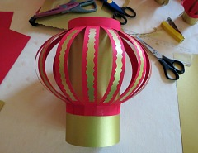
- Secure the remaining side with glue and a couple of staples if needed

Step 10:
- Cut two stripes of gold paper 1/2" thick
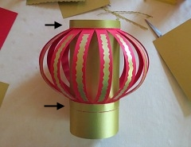
- Glue them to the top and bottom of the lantern (it covers all the tape, staples, etc.)

Step 11:
- Cut any excess gold tube at the bottom if you will be placing the lantern on a table, or
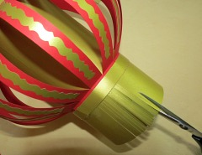
- Cut thin stripes at the bottom to form the fringe of the lantern if you will hang it

Step 12:
- Make the handle with a strip of gold paper
- Glue on both sides at the top
- Ready!

