**This half of Spring term in Year 2 we will be learning... l**

**DT**

This half term we will focus on DT and making a model castle. Children will investigate different structures and how they stand. They will plan, make and review their model which will have a moving part.

**Numeracy**

Children will continue to develop their skills in numbers and calculations. This half term will continue to look at shapes and learn the correct vocabulary so that we can describe the properties of shapes accurately. We will also be developing skills to look at fractions. Daily, children will continue to develop their number fluency through mental maths.

**Literacy**

Children will be taught Literacy on a daily basis with an hour lesson each day. Children will be taught through topic related literacy lessons focusing on fiction writing, exploring characters, setting and story structure. We will be learning to use varied sentence openers, connectives, adjectives and similes in order to develop writing style. Children will also become familiar with non-fiction text relating to our topic.

**Computing**

In Computing, children will be looking at how digital content can be presented in different forms. They will have a go at presenting their own ideas.

**Castles!**

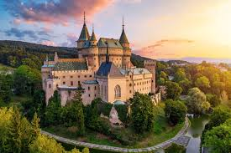

**Geography**

This half term we will focus on Geography. We will look at the United Kingdom and use geographical vocabulary to describe the features of where castles are located and the features of the castle themselves. We will also develop map skills, reading, looking at symbols and drawing maps.

**R.E & PSHCE**

In R.E children will learn about the Easter story and how Christians celebrate Easter.

**PSHCE**

In PSHCE we will continue to look at friendship and how we can stay positive and look forward to things on the horizon.

**Music**

This half term we are going to listen to a range of different kinds of music from the past.

Some pieces of music you will enjoy and others you won’t and you can explain your reasons.

**Science**

In science, we will continue to look at materials, how they can be changed and we will also look at new materials and their creators.

**P.E**

This half term we will focus on gymnastics, children will practise and develop their skills of balancing, rolling, jumping and creating routines.

**S**

**Year 2 - Spring Term 2 2021**

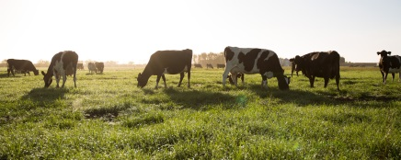

**Additional Information:**

**Reading:** Please hear your child read/read with your child every day, either from a school reading book, or a book from home. Please contact me if your child needs any new books whilst learning at home.

**Spellings:**

Your child will bring home new words to learn. They will be tested every Friday. Please help them to practise their spellings.

**P.E:**

There are two P.E. sessions per week and this half term we will focus on gymnastics and keeping fit. Your child should continue to dress appropriately for PE on their allocated PE days. PE uniform should consist of black/blue jogging bottoms, white t-shirt and school jumper as well as trainers.

**Water Bottles and snacks:**

Please continue to send your child to school each day with a named water bottle.

At morning break time children can have a healthy snack such as piece of fruit or vegetables, which should be brought in from home**.**

**Homelearning:**

Homelearning will continue to be set whilst required and can be accessed via the school website. We will begin to have some live story sessions on Google meet. More information will follow. Please continue to email work to the Year 2 address.

[Year2home@heddon-school.co.uk](mailto:Year2home@heddon-school.co.uk)

When school does return, if possible, we will finish this half term with a ‘Kings and Queens’ day, where children can dress up, we will have a banquet and explore some sports, games and castle crafts. Lets keep fingers crossed that this can go ahead!

Mrs Southern