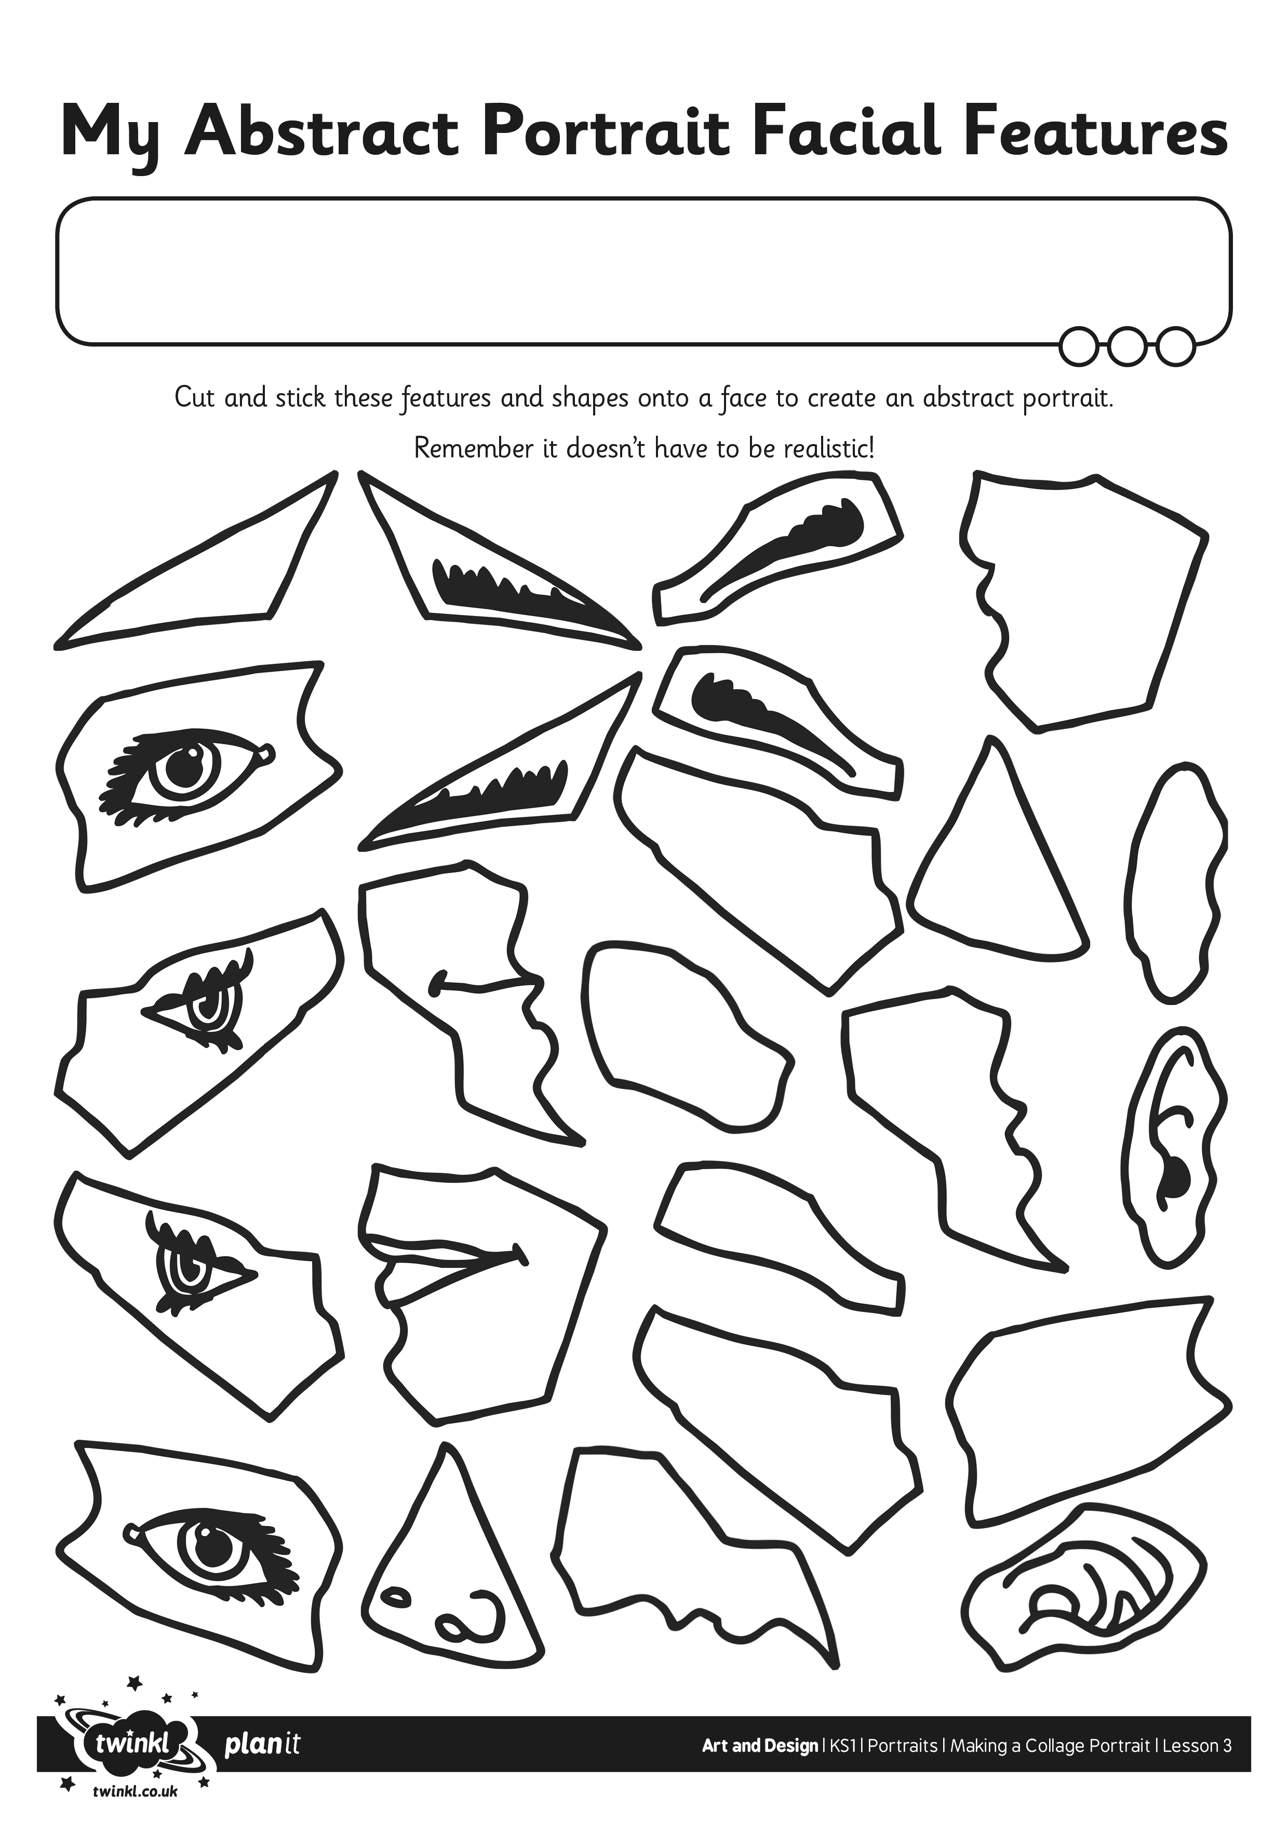
I can use collage materials to create an abstract portrait.

