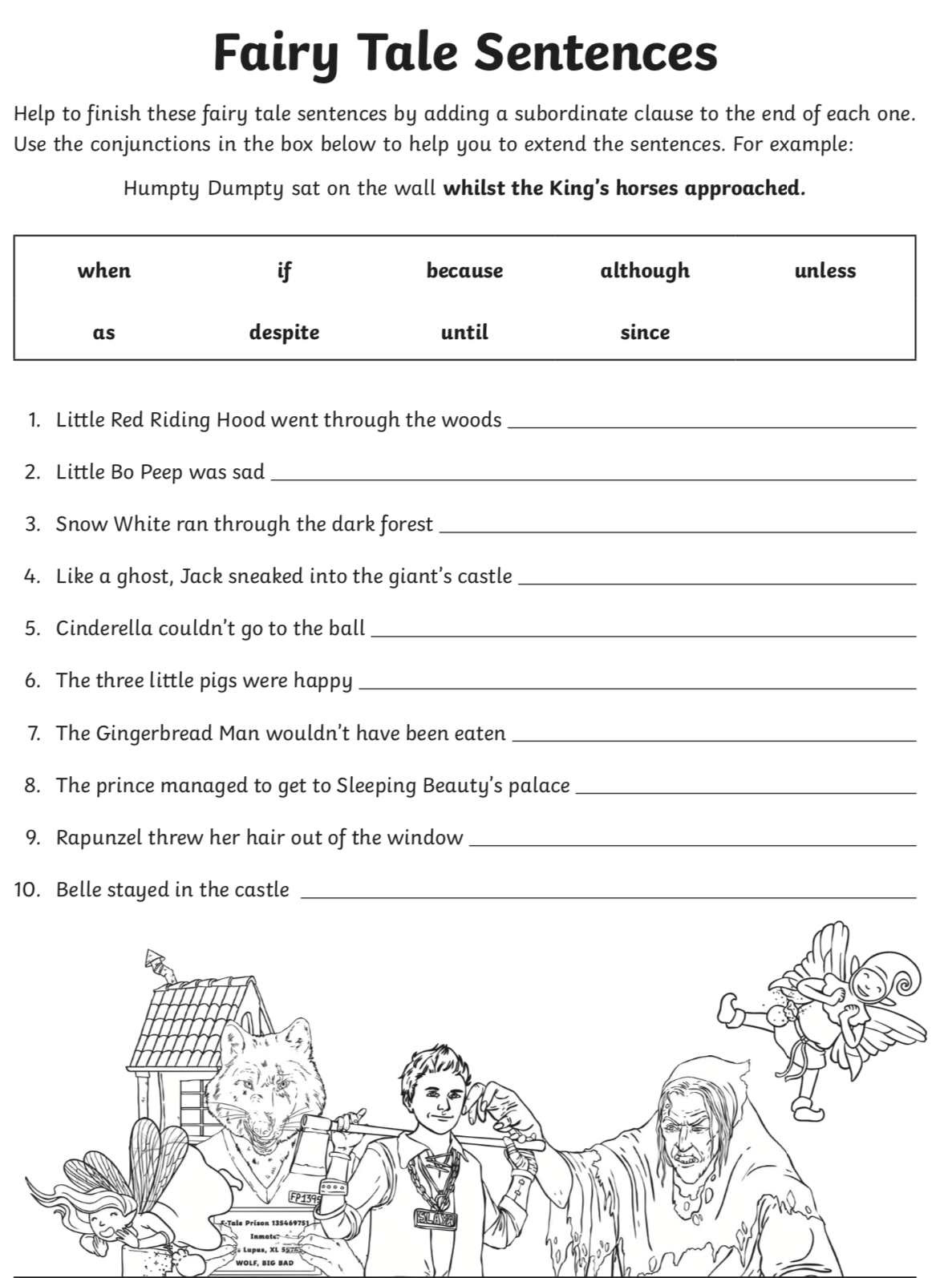
Rewrite the following sentences and add a subordinating clause to the beginning, middle or end of the sentences to extend them. Use the subordinating conjunctions above to help you.

- Once there lived a rabbit who was made almost entirely of china.

- Edward Tulane felt himself to be an exceptional specimen.
- Edward’s mistress was a ten year old girl named Abilene.
- The china rabbit was in possession of an extraordinary wardrobe.

- Abilene positioned the chair so that Edward was looking out of the window.

