Wednesday 6th January 2021

L.O: I can find out about Grace Darlings life in the past from a photograph. I can understand how Grace Darling’s life is different from my own.

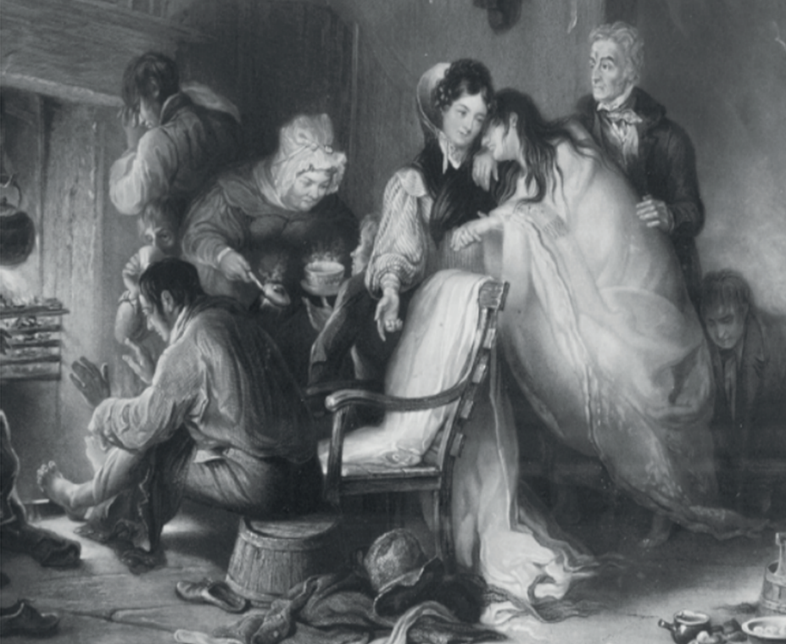

1)What are they wearing?

3)What are they doing?

2) Was this picture taken a long time ago? How do you know?

4) What else can you find out from the picture?

This is a picture of my family in our home

What is different about your family picture and Grace Darling’s family picture?





