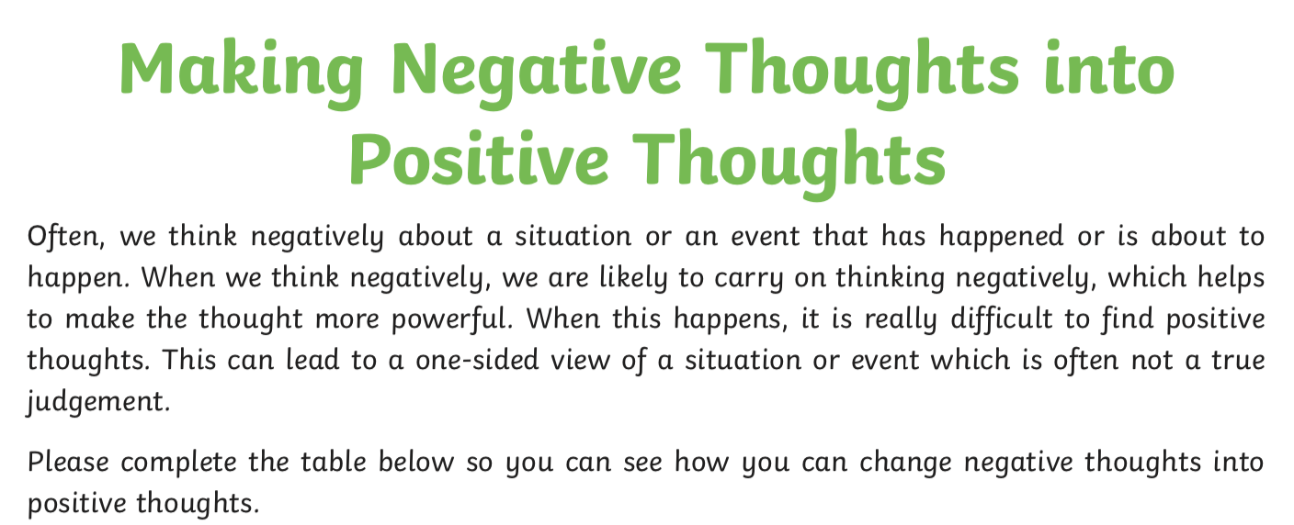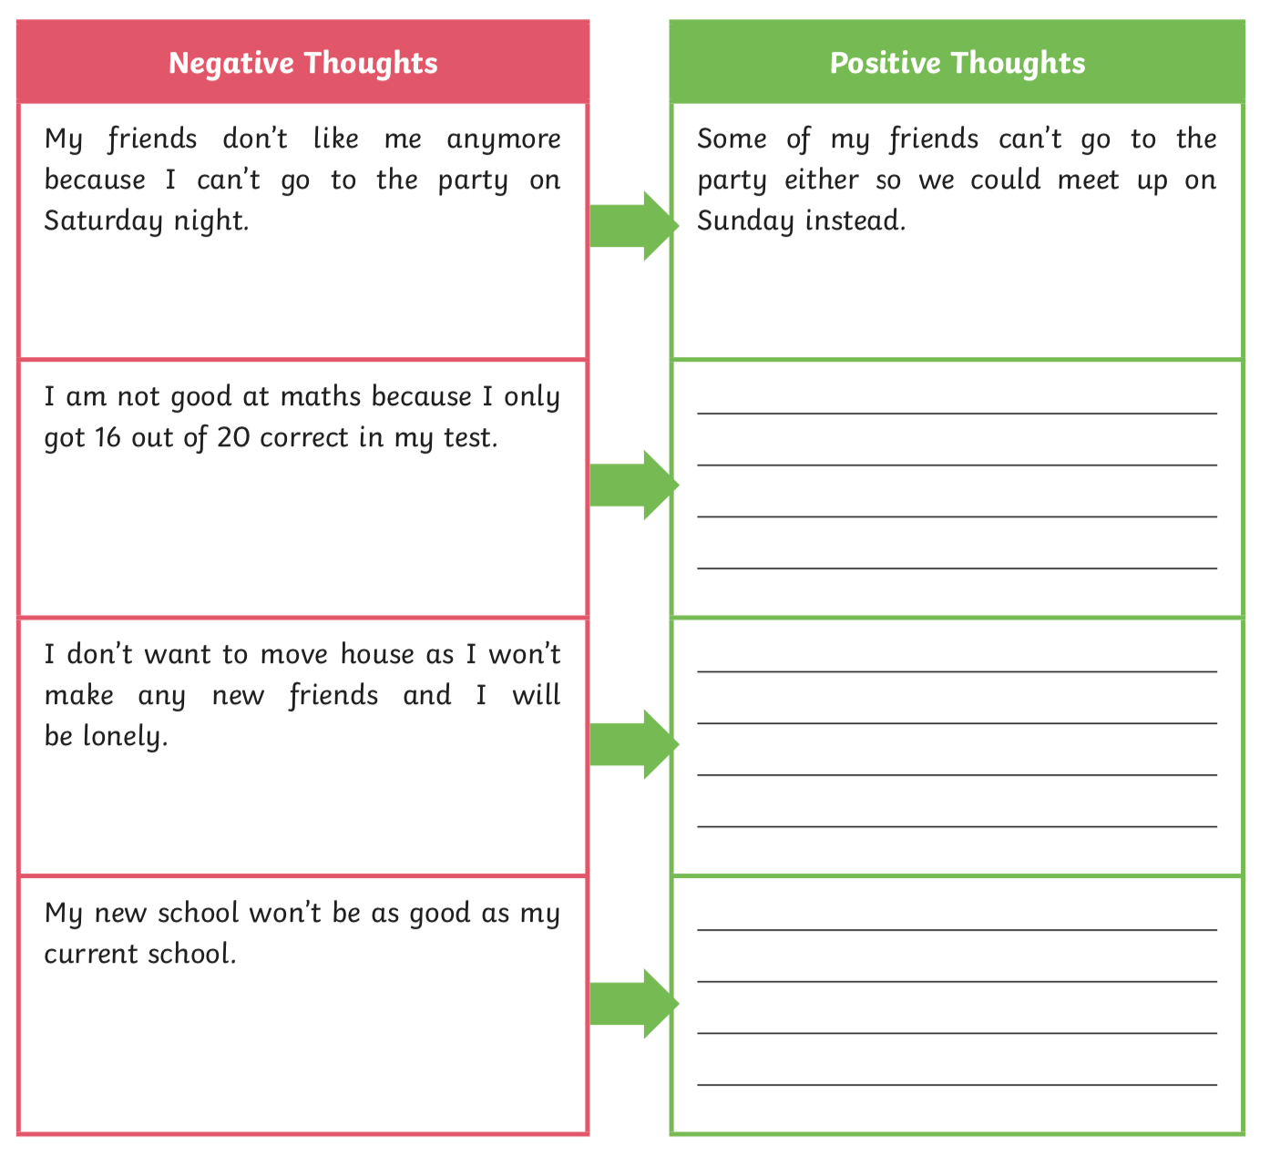

My friends don’t like me anymore because I can’t go out and play with them.

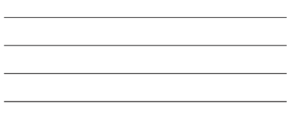

I am not good at maths because I only got 14 out of 20 correct.

I don’t want to move house as I won’t make any new friends and I will be lonely.

I don’t see the point in doing work at home, I am missing school.