**This Spring term in Year 2 we will be learning... l**

**Literacy**

Children will be taught Literacy on a daily basis with an hour lesson each day. Children will be taught through topic related literacy lessons focusing on fiction writing, exploring characters, setting and story structure. We will be learning to use varied sentence openers, connectives, adjectives and similes in order to develop writing style. Children will also become familiar with non-fiction text relating to our topic.

**Art and DT**

The children will look at portraits of monarchs and famous landscapes from different periods. We will explore a range of art techniques such as pencil, paint, textiles and sculpture to create their own portraits. In DT we will be exploring materials and model making.

**Numeracy**

Children will continue to develop their skills in multiplication and division, looking at different representations of these. multiplication tables and related division facts. They will be solving real life problems involving counting, adding, subtracting, doubling, halving, multiplication and division. We will learn about the fractions of numbers and shape.

**Computing**

In Computing, children will be using search engines on the internet to help them research information about monarchs of the past. They will then word process this information. They will revisit e-safety during this time too**.**

**Kings, Queens & happy ever after!**

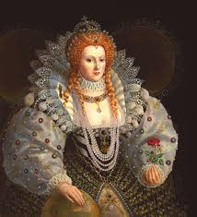 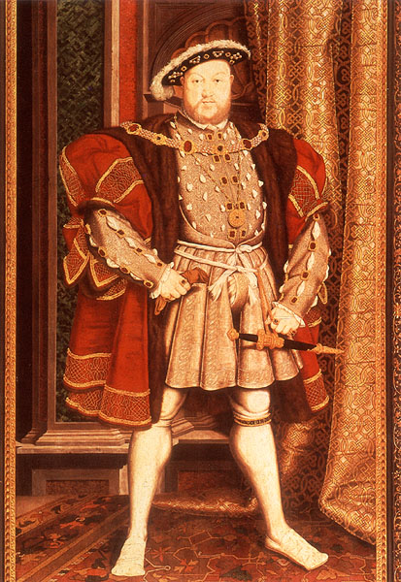 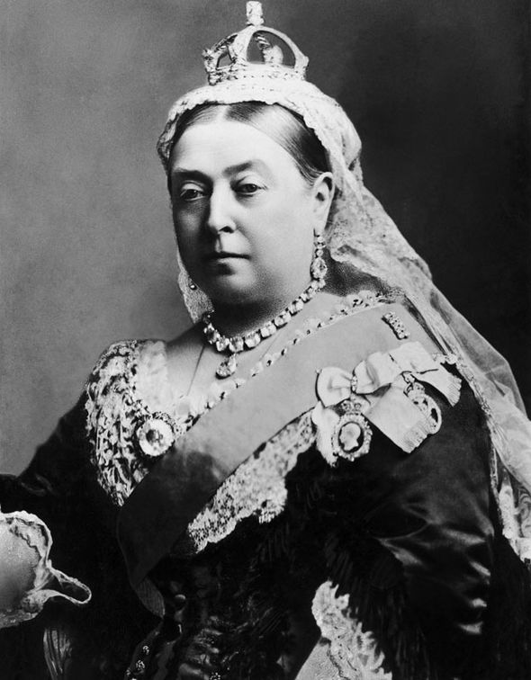

**History**

In History children will learn about the history of the British Monarchy, in particular, different Kings and Queens that have ruled. They will learn about how life during specific reigns differs to our lives today.

**Music**

This half term we are going to listen to a range of different kinds of music from the past.

We will look at how music has changed over years as well as exploring and copying rhythms.

**R.E & PSHCE**

In R.E children will be taught about what Christians believe with regards to the good news that Jesus brings us. They will use discussion, art work and writing activities to explore their ideas.

**P.E**

The children will take part in 2 P.E lessons each week. One lesson will be skills based, led by a PE specialist and will focus on gymnastics. The second lesson will emphasise the importance of fitness for being healthy.

**Science**

In science we will be exploring materials and their properties. We will plan, carry out and evaluate experiments on materials.

**S**

**Year 2 - Spring Term 1 2021**

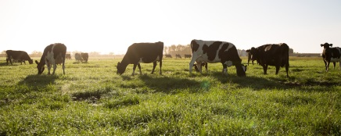

**Additional Information:**

**Reading:**

Please hear your child read/read with your child every day, either from a school reading book, or a book from home. Please ensure that you record when you have read with your child in their homework diary. Children should bring their book back to school on Friday when we will give them a new book.

**Spellings:**

Your child will bring home new words to learn. They will be tested every Friday. Please help them to practise their spellings.

**Homework:**

Weekly homework will consist of reading and spelling. During this topic we will also ask that the children research a monarch of their choice and create a poster/project to present to their peers. Further information on this will follow.

**P.E:**

There are two P.E. sessions per week and this half term we will focus on gymnastics and keeping fit. Your child should continue to dress appropriately for PE on their allocated PE days. PE uniform should conists of black/blue jogging bottoms, white t-shirt and school jumper as well as trainers.

**Water Bottles and snacks:**

Please continue to send your child to school each day with a named water bottle.

At morning break time children can have a healthy snack such as piece of fruit or vegetables, which should be brought in from home**.**

Finally, if you have any concerns or questions regarding your child, please do not hesitate to contact me by email or by phoning school.

[Year2home@heddon-school.co.uk](mailto:Year2home@heddon-school.co.uk)

Mrs Southern