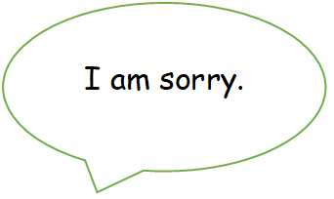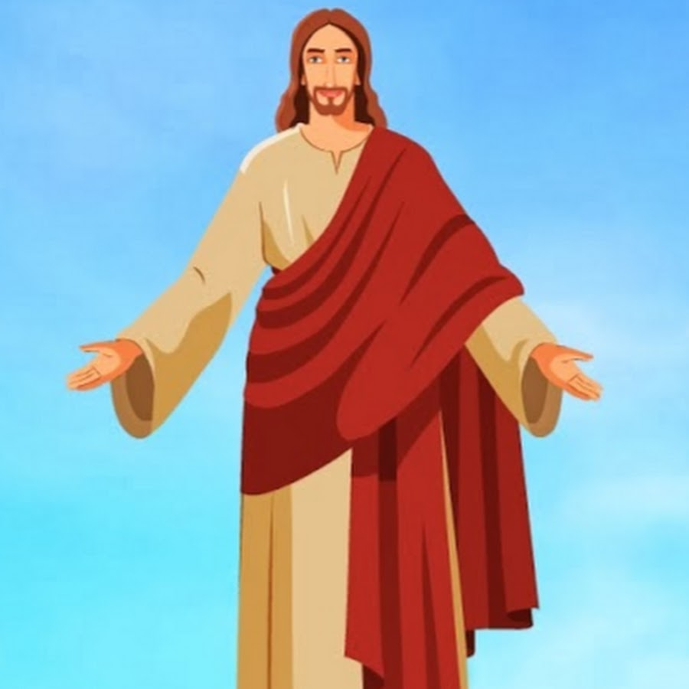

Draw two pictures of people who need forgiving. Jesus has forgiven them because they are sorry. Have a think, should we forgive people who say sorry to us and why?

I am sorry.

You are forgiven.