Place | Owner | Picture | Edward’s name
Egypt Street | Abilene | 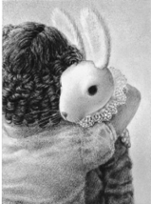 | Edward
Ocean Floor

Fisherman’s Cottage

Garbage Dump

Across the countryside

Vegetable Garden as a scarecrow

The Miraculous Journey of Edward Tulane
I can track a character’s journey within a story.

