Year 3 Home Learning 21/01/2020 Daily Timetable

Morning Tasks | Daily mental maths: See below.  Read a chapter of your book.
English | Work your way through the PowerPoint and then complete the activity.
Maths | Today we are focussing on our knowledge of pence, from Year 2.  Work your way through the PowerPoint and then complete the worksheet.
Science | Watch the following video: https://classroom.thenational.academy/lessons/what-are-magnets-cgvkee

If you have any questions, please contact me at year3home@heddon-school.co.uk

Please send all completed work back to the above email address at the end of each day. This can be attached as an uploaded photo.

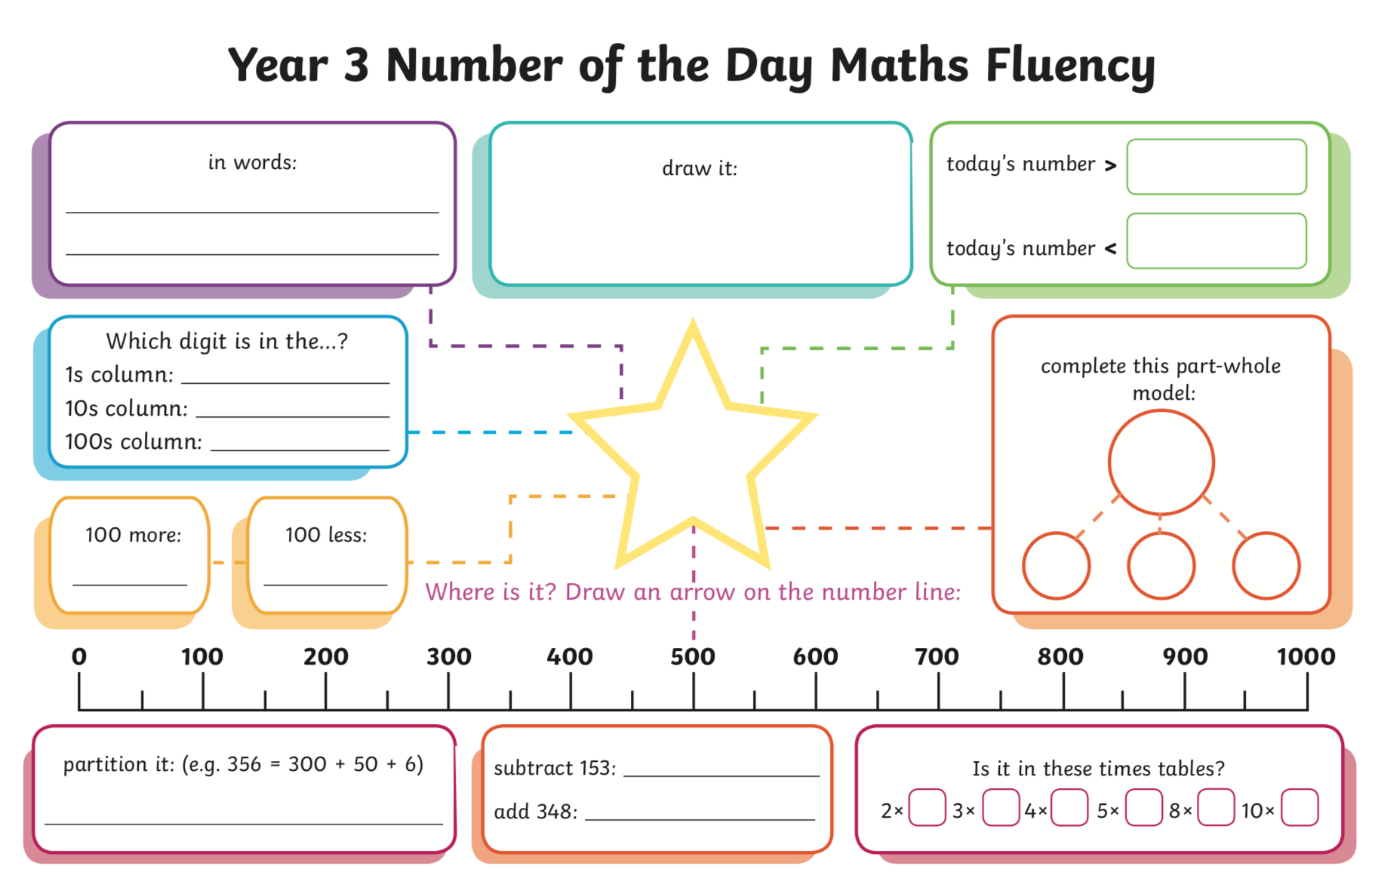
521

