Year 3 Home Learning 20/01/2020 Daily Timetable

Morning Tasks | Daily mental maths: See below.  Handwriting: see below.  Read a chapter of your book.
English | Work your way through the PowerPoint and then complete the activity on the worksheet.
Maths | Today we are focussing on consolidating multiplication and division.  Work your way through the PowerPoint and then complete the end of unit assessment.
Geography | Today you are going to be looking at geographical features of continents. Go through the PowerPoint and record your research using the worksheet.
French | Today we are learning the names for parts of the body. Go through the PowerPoint and then complete the activity.

If you have any questions, please contact me at year3home@heddon-school.co.uk

Please send all completed work back to the above email address at the end of each day. This can be attached as an uploaded photo.

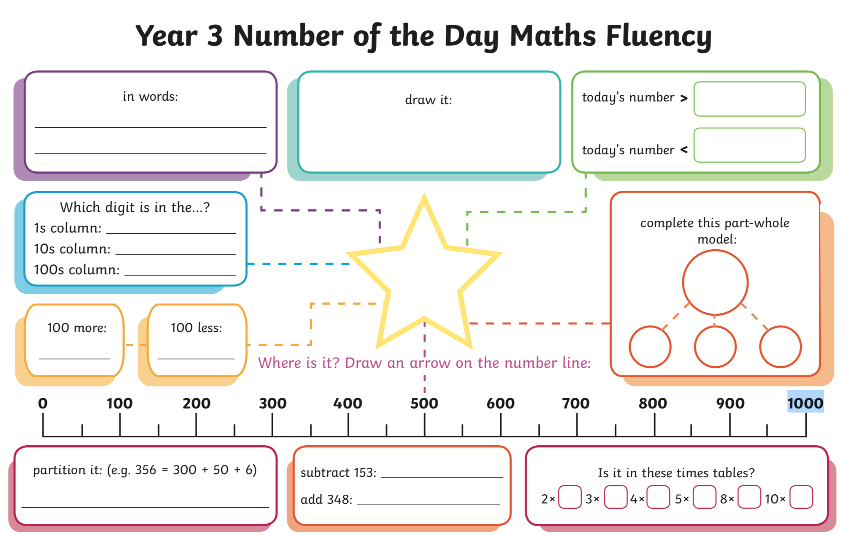
322
