Year 3 Home Learning 19/01/2020 Daily Timetable

Morning Tasks | Daily mental maths: See below.  Handwriting: see below.  Read a chapter of your book.
English | Work your way through the PowerPoint and then complete the comprehension activity.
Maths | Today, our objective is: ‘I can solve multiplication and division problems’.  Work your way through the PowerPoint and then complete the worksheet.
DT | Go through the PowerPoint and then complete the worksheet.
PE | https://www.youtube.com/user/CosmicKidsYoga

If you have any questions, please contact me at year3home@heddon-school.co.uk

Please send all completed work back to the above email address at the end of each day. This can be attached as an uploaded photo.

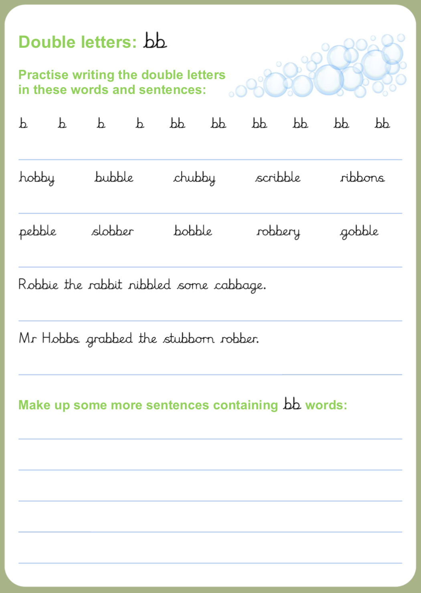
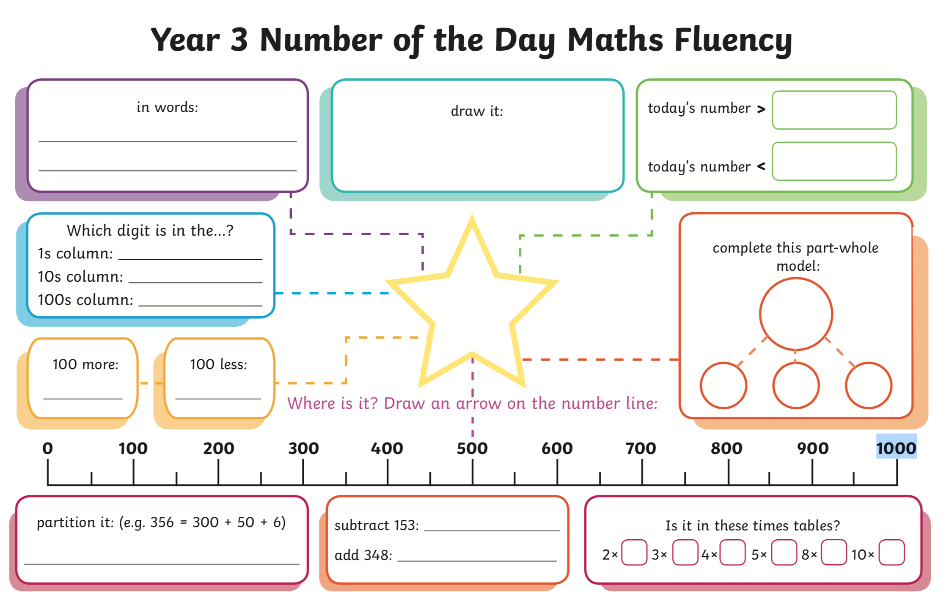
249

