Year 3 Home Learning 27/01/2020 Daily Timetable

Morning Tasks | Daily mental maths: See below.  Complete the spelling Worksheet below.
English | Work your way through the PowerPoint and then complete the activities.
Maths | Today our objective is ‘I can add amounts of money that are given in pounds and pence’.  Work your way through the PowerPoint and then complete the worksheet.
Geography | Today you are going to be looking at capital cities. Go through the PowerPoint and complete the worksheet.
French | Work your way through the PowerPoint.

If you have any questions, please contact me at year3home@heddon-school.co.uk

Please send all completed work back to the above email address at the end of each day. This can be attached as an uploaded photo.

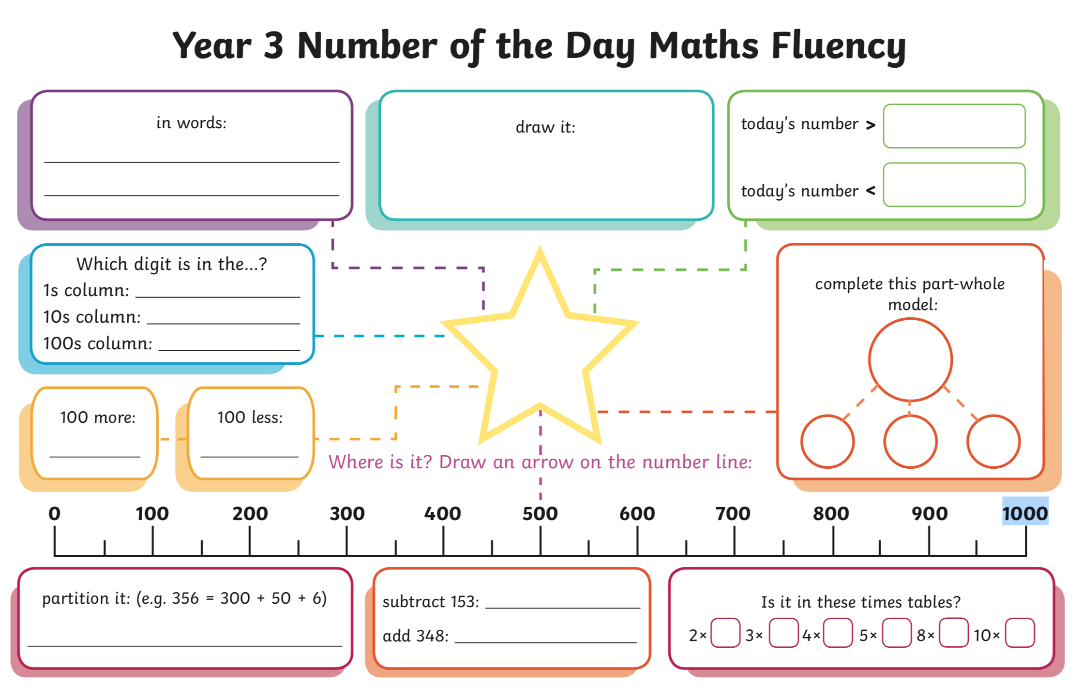
182

