Year 3 Home Learning 11/01/2020 Daily Timetable

Morning Tasks | Daily mental maths: See Maths PowerPoint.  Spelling rule- see English PowerPoint.
English | Go through the PowerPoint. Read Chapter 3 and 4. Draw a sequence of pictures to summarise the events within Pellegrina’s story.
Maths | Today, we are going to continue to multiply a 2 digit number by a 1 digit number.  Work your way through the PowerPoint.
RE | Go through the PowerPoint. We are continuing to look at the Trinity.
Computing | Complete the ‘Technology outside school’ activity on Purple Mash.

If you have any questions, please contact me at year3home@heddon-school.co.uk

Please send all completed work back to the above email address at the end of each day. This can be attached as an uploaded photo.

Purple Mash Blog-

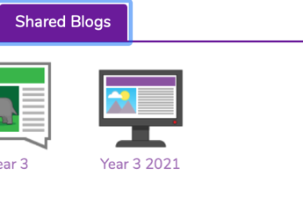
So that we can all stay in contact, I have set up a Year 3 blog on Purple Mash. To access this, log onto your Purple Mash account, then go to ‘sharing’, then ‘shared blogs’ and click in ‘Year 3 2021’.

