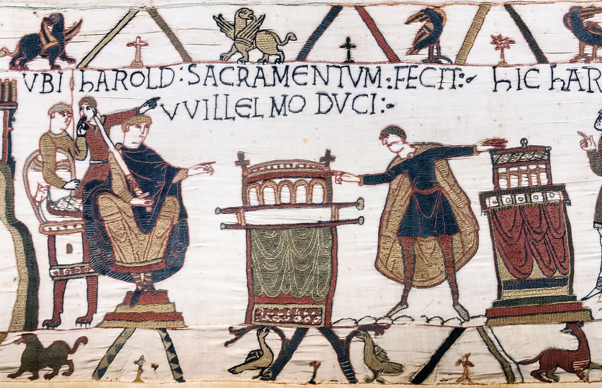

As King of England, William was keen to find our how rich his new country was. He wanted rich people to pay the government tax (money). William carried out a survey and collected information in the ‘Doomsday Book’. This book still exists today and is the earliest surviving public record in England. William died in 1087 after falling from his horse.

Being King of England

*The Bayeux Tapestry shows key events from the Battle of Hastings.*

William The Conquerer!

Early Life

The Battle of Hastings

Harold hoped to take the Normans by surprise, but by the time he and his army arrived William was ready and waiting. During the [Battle of Hastings](https://kids.britannica.com/kids/article/Battle-of-Hastings/476272), which took place on October 14, 1066, Harold was killed. Without their leader, the English forces fled. Although there was some resistance to the Norman invasion later, William had won the English crown.

William was born in Normandy, in northern [France](https://kids.britannica.com/kids/article/France/345690), in about 1028. He was the son of Robert, duke of Normandy. Because Robert had no children, William inherited the dukedom when his father died in 1035.

William was very ambitious. He wanted control of more lands, and in 1063 he conquered the French province of Maine. Next he set his sights on England.