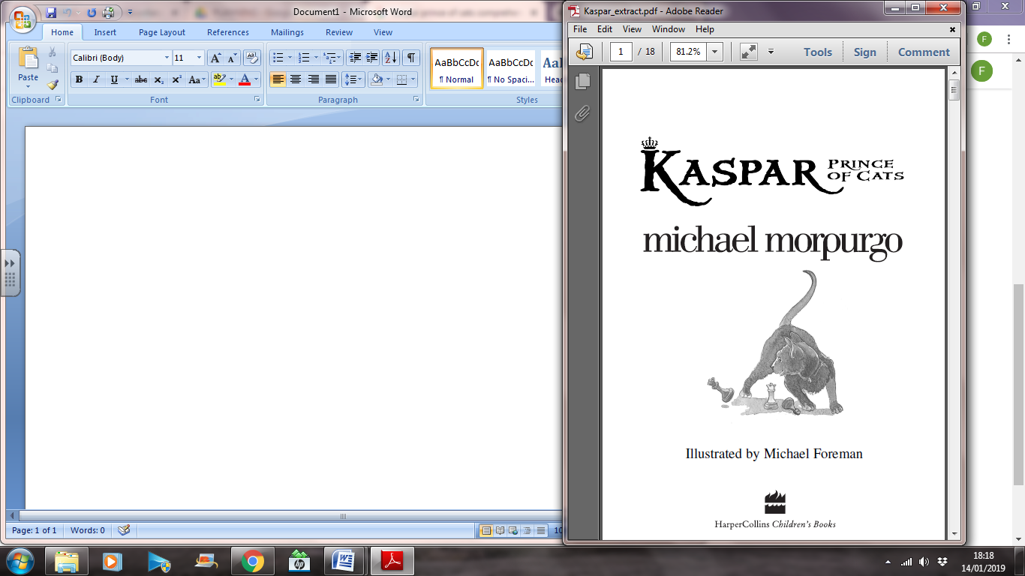

**Chapter Eight: *Women and Children First***

*Don’t forget to use textual evidence in your answers!*

1. On what deck of the Titanic was Lizziebeth’s cabin? What was her cabin number?
2. Which items does Mrs. Stanton not want to leave behind?
3. ‘*As I got up on to the boat deck, I noticed that the boat was listing noticeably more severely than before…*’ What do you think listing means in this context?
4. Why does Johnny get called an ‘idiot’ by a crew member? Do you agree or disagree?
5. Where was Kaspar when Johnny found him?
6. Johnny is wondering, ‘*how something this terrible could be so beautiful*.’ Explain what Johnny means.
7. Overall, what do we learn about Mr. Lightoller in this chapter?



**Challenge: Can you write your own questions**

**about this chapter?**

Try and create one fact retrieval question,

one inference question and one question

about vocabulary.