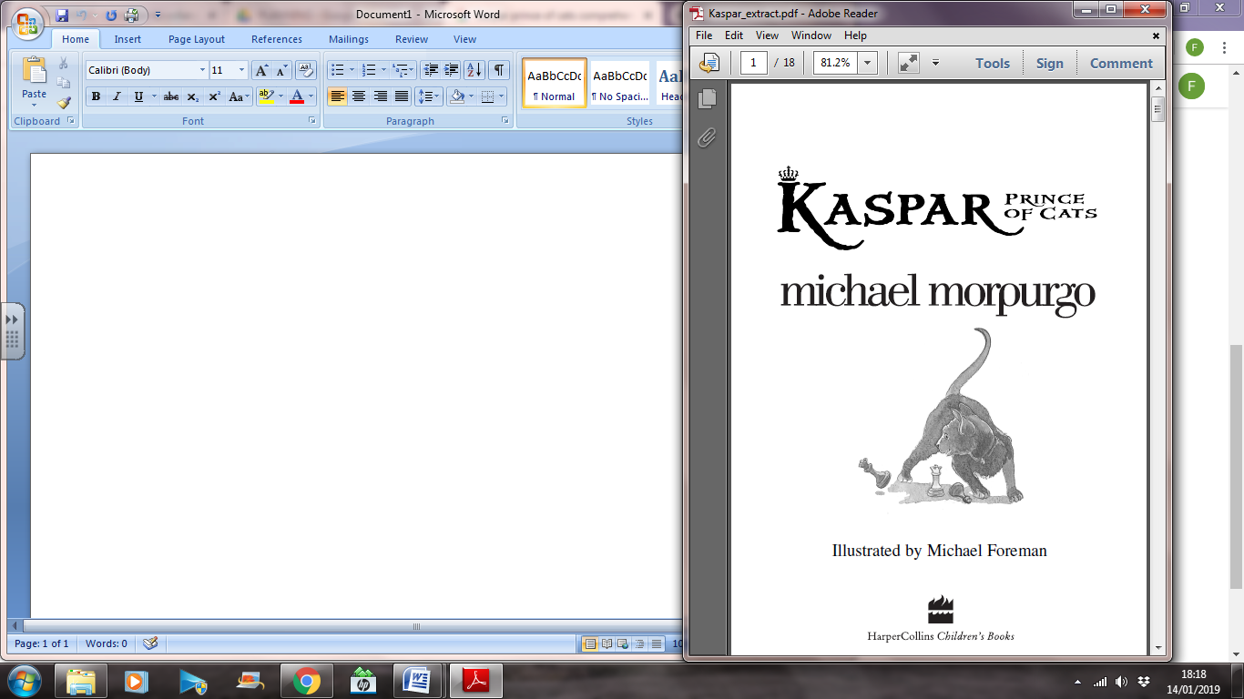



1. What is the name of the hotel where Johnny works?

2. What are Johnny’s main duties as a bell-boy?

3. What is the nickname given to Mrs. Blaise and why?

4. Look at page 11. What do you think the word *misdemeanour* means?

5. “*She didn’t just walk to the lift, she sailed there, magnificently*...” What does this sentence suggest about how the Countess moves?

6. How does Johnny feel when he accompanies the Countess in the lift? Why do you think he feels this way?

7. Find and copy three prepositional phrases on page eighteen.

8. Look at page 19. Scan for the word tentatively. Look up the word in your dictionary. Why did Johnny stroke Kaspar *tentatively*?

9. Why is the Countess staying in London?

10. In your own words, summarise the events on

page 21 in one or two sentences.