When Edward the Confessor died in 1066 four people thought they should be king.
Write some things you found out about each one.
Edgar the Atheling | Harold Godwinson
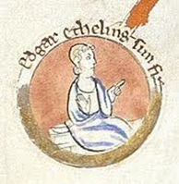  ______________________________  ______________________________  ______________________________  ______________________________ | 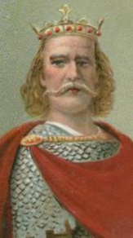  ______________________________  ______________________________  ______________________________  ______________________________
William Duke of Normandy | Harold Hardrada
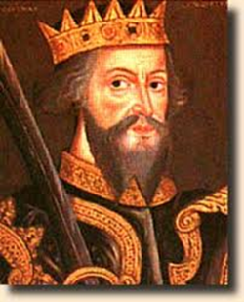  ______________________________  ______________________________  ______________________________  ______________________________ | 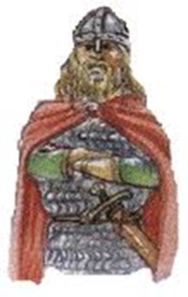  ______________________________  ______________________________  ______________________________  ______________________________

I think _____________________________ would be the best king because__________________________________________________________________________________________________________________________________________________________________

