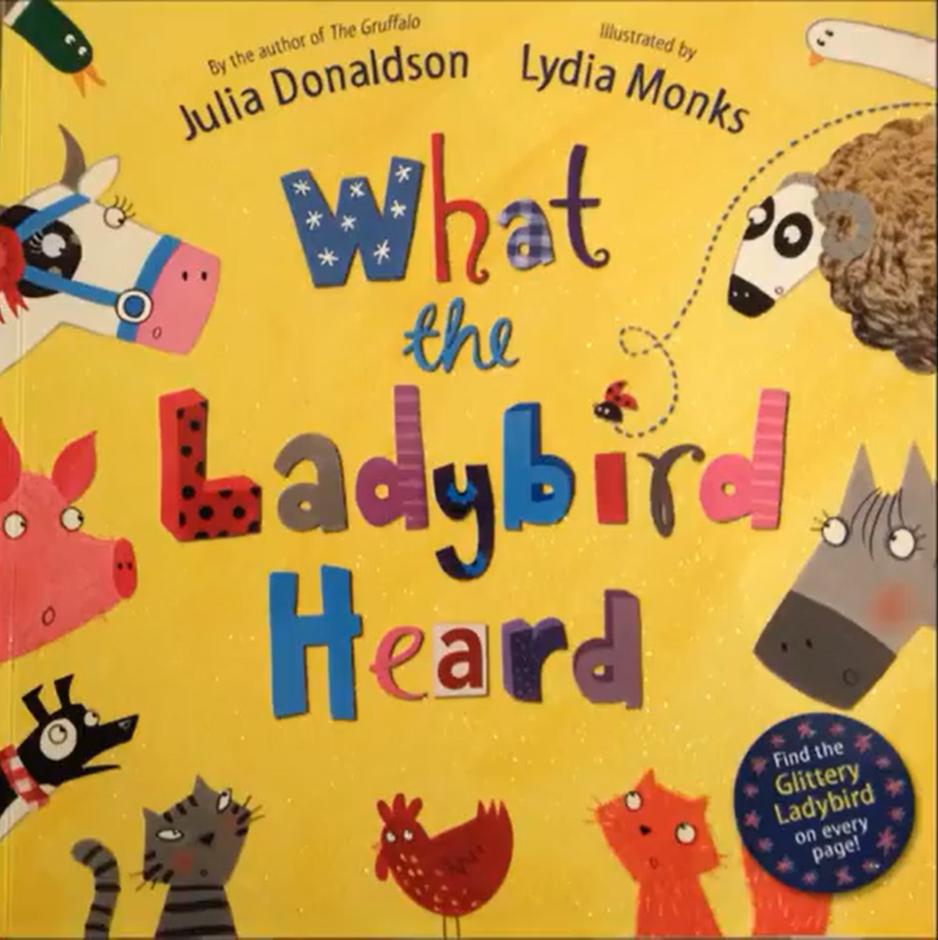
Task: Now we can see the front cover of our story. The title is ‘What the lady bird heard’. Do we have any more information about the story? Based on the work we have done so far and, on the title, can you write a sentence about what you think the lady bird has heard? Then read up to slide 7. Stop before 8.
Task 2: Can you write some questions you would like to ask about what you have read so far? Remember to use capital letters and question marks.

