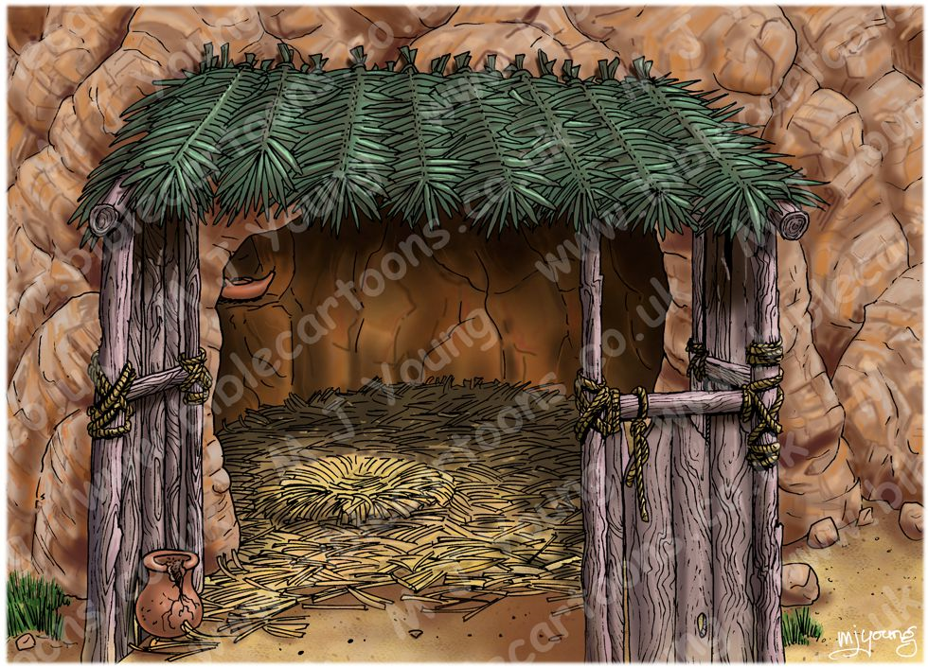
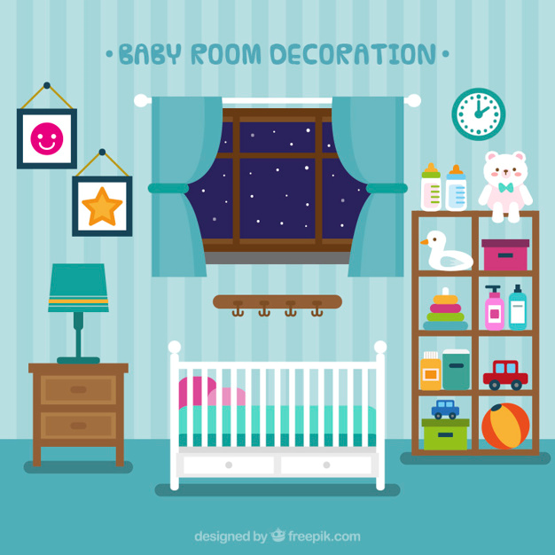
Task: Write a sentence comparing a baby bedroom now and the stable Jesus was born in

