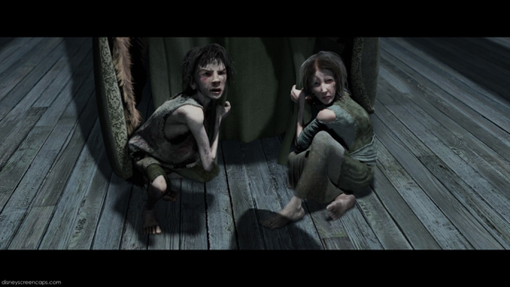
Ignorance and Want
Why would Dickens choose children to symbolise the problems in society?

From the foldings of its robe, it brought two children; wretched, abject, frightful, hideous, miserable. They knelt down at its feet, and clung upon the outside of its garment.
Look at the list of adjectives of the children. What do they reveal about the problems in society?
"Oh, Man, look here! Look, look, down here!" exclaimed the Ghost.
They were a boy and a girl. Yellow, meagre, ragged, scowling, wolfish; but prostrate, too, in their humility. Where graceful youth should have filled their features out, and touched them with its freshest tints, a stale and shrivelled hand, like that of age, had pinched, and twisted them, and pulled them into shreds. Where angels might have sat enthroned, devils lurked, and glared out menacing. No change, no degradation, no perversion of humanity, in any grade, through all the mysteries of wonderful creation, has monsters half so horrible and dread.
Why are the children monsters? How will they behave in the future? Why?
Why are the children described as being old before their time?
Scrooge started back, appalled. Having them shown to him in this way, he tried to say they were fine children, but the words choked themselves, rather than be parties to a lie of such enormous magnitude.
"Spirit, are they yours?" Scrooge could say no more.
If the children belong to man, why do they cling to the Ghost of Christmas Present?
"They are Man's," said the Spirit, looking down upon them. "And they cling to me, appealing from their fathers. This boy is Ignorance. This girl is Want. Beware them both, and all of their degree, but most of all beware this boy, for on his brow I see that written which is Doom, unless the writing be erased. Deny it!" cried the Spirit, stretching out its hand towards the city. "Slander those who tell it ye. Admit it for your factious purposes, and make it worse. And abide the end."
How does Ignorance relate to Scrooge? Why does the ghost focus on him?
"Have they no refuge or resource?" cried Scrooge.
"Are there no prisons?" said the Spirit, turning on him for the last time with his own words. "Are there no workhouses?"
Who’s words are these? Why does the ghost repeat them?

