Heddon St Andrew’s CofE
Primary School
Winter Wonderland

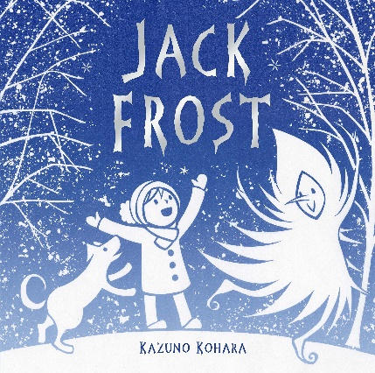

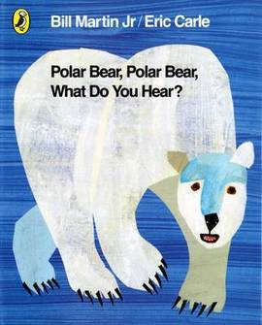

SPRING 1 2020
Reception - Mrs Cubbage, Mrs Haddock,
Mrs McGurk
Nursery – Miss Kerridge and Miss Ross

This term our topic is ‘Winter Wonderland!’
The aim of this leaflet is to give you an overview of the skills
to be covered during the study of this topic. Due to the child focussed
curriculum in the Foundation Stage, we are unable to specify exactly
what we will be doing as it can change regularly depending on the interests
and abilities of the children.

As with each topic we will use a linked text to support the learning. We will begin focusing on well-known stories learning about how they are structured before taking the children’s lead with stories they are interested in.
The seven areas of the Early Years Foundation Stage will continue to be explored and children will have lots of opportunities to initiate their own learning. By the end of the topic children will have learned to explore books, handle them with care and enjoy re-telling a variety of stories. Within these areas the children will be learning skills and working towards specific goals. The goals which they will be working towards achieving by the end of the Foundation stage include:

Personal, Social and Emotional Development
Throughout this topic there will be opportunities for children to show sensitivity to their environment and the people around them, to work collaboratively and to express feelings in response to the stories they hear. We will also aim to develop the children’s understanding of what is right and wrong and other moral dilemmas.
Children will;

Understand what is right, what is wrong and why

Consider the consequences of their words and actions for themselves and others

Understand that people have different needs, views, cultures and beliefs, that need to be treated with respect

Work as part of a group or class, taking turns and sharing fairly,

Understand that they can expect others to treat their needs, views, cultures and beliefs with respect

Communication, Language and Literacy
The activities during this topic provide children with opportunities to respond to a variety of real life, imaginative and role-play situations. Describing characters, retelling a well know story, writing and looking at labels will help children to develop their early writing skills. Reading different stories will widen children’s vocabulary and help them to express themselves clearly. The repetitive language in lots of well-known stories will help children to retell stories and encourage them to make up their own.
- Enjoy listening to and using spoken and written language and readily turn to it in their play and learning
- Use language to imagine and re-create roles and experiences
- Listen with enjoyment and respond to stories, songs and other music, rhymes and poems and make up their own stories, songs and rhymes
- Extend their vocabulary, exploring the meanings and sounds of new words
- Link sounds to letters, naming and sounding the letters of the alphabet.
- Show an understanding of the elements of stories, such as main character, sequence of events and openings and how information can be found in non-fiction texts to answer questions about where, who, why and how.
- Retell narratives in the correct sequence, drawing on language patterns of stories.
- Write their own names and other things such as labels and captions and begin to form simple sentences, sometimes using punctuation.
- To use their phonic knowledge to write simple regular words and make phonetically plausible attempts at more complex words
- Use a pencil and hold it effectively to form recognisable letters, most of which are correctly formed.

Mathematical Development
Stories are a source of interest for children and many contain numbers, shape, size of people, objects and animals.
Children will be able to;

Count reliably objects, actions and sounds
- Subitise small quantities in familiar patterns e.g. dice patterns
- Use language such as “more” or “less” to compare two numbers
- In practical activities and discussion begin to use the vocabulary involved in adding and subtracting.

Use language such as “greater”, “smaller”, “heavier” or “lighter” to compare quantities.

Use everyday words to describe position

Talk about, recognise and recreate simple patterns.

Use language such as “circle” or “bigger” to describe the shape and size of solids and flat shapes.
- Use developing mathematical ideas and methods to solve practical problems

Knowledge and Understanding of the World
We will explore the settings and environments in which the stories occur, explore the natural world around us and learn about different environments. We will also learn about the weather during winter and common seasonal changes.
Children will:
- Describe what they see, hear and feel outside
- Understand the changes that come with different seasons
- Find out about and identify the uses of everyday technology and use information and communication technology and programmable toys to support their learning

Find out about their environment and talk about those features they like and dislike

Physical Development
Children will practise handling a range of tools with increasing control when using playdough, cooking, printing and painting. Activities will often be linked to stories allowing the children opportunities to develop control and coordination whilst working in an imaginative way. By playing whole group games, children will become aware of space and the needs of others.
Children will;

Handle tools such as pencils, scissors, paintbrushes safely and with increased control

Use their core muscle strength to achieve a good posture when sitting at the table or on the floor

Show awareness of space, of themselves and of others

Travel around, under, over and through balancing and climbing equipment

Recognise the changes that happen to their bodies when they are active

Creative Development

Children will experience working with a variety of materials and learn new skills using their imaginations.
Children will be able to;
- Create or construct with a plan in mind
- Explore colour mixing to create new colours or shades of colour
- Listen attentively to and talk about music
- Develop storylines in their own play

ADDITIONAL INFORMATION FOR PARENTS
Reading:
All children in Early Years are issued with a library book; Nursery on Mondays and Reception on Fridays. Please ensure the book is in school the following week along with their Reading Diary so that they can exchange it. Many children in Reception have been issued with a reading book. Please encourage your child to read their book at least 3 times before requesting a change; once to decode and discuss the story, twice to improve their fluency and speed of decoding words and to further develop their understanding of the story and characters and thirdly to enable them to read with fluency, expression and intonation appropriate to the text. Reading books will be changed each Monday if your child is sufficiently competent at reading the book.

PE
- Nursery PE - Monday
- Reception PE – Monday and Tuesday

- Nursery and Reception – Commando Joes team building activities – Friday

Please ensure your child comes to school appropriately dressed on their PE days. Where possible, PE will take place outside.

Show and Tell
Parents are encouraged to share news from home via Tapestry for Show and Tell in class. Being able to share news and talk about things they have been busy doing at home has a positive effect on children’s confidence and also helps their speaking and listening skills.

