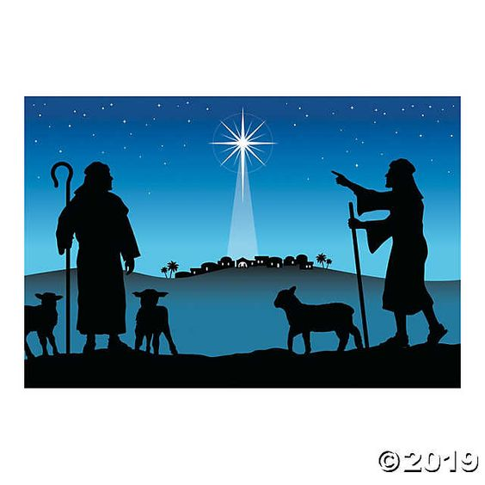
Task: Draw a silhouette of the shepherds looking at the star using whatever resources you like/ have available. Perhaps if you have a printer you might like to use this picture to recreate it. You could cut the shepherds out and draw/ colour the background using any resources you have. – Paint, colouring pencils, colouring pens, crayons, etc.

