Answer to Monday’s puzzle:

Dominic the Donkey was missing!

Try to win Tuesday

Have a game of BEETLE and see if you can win!

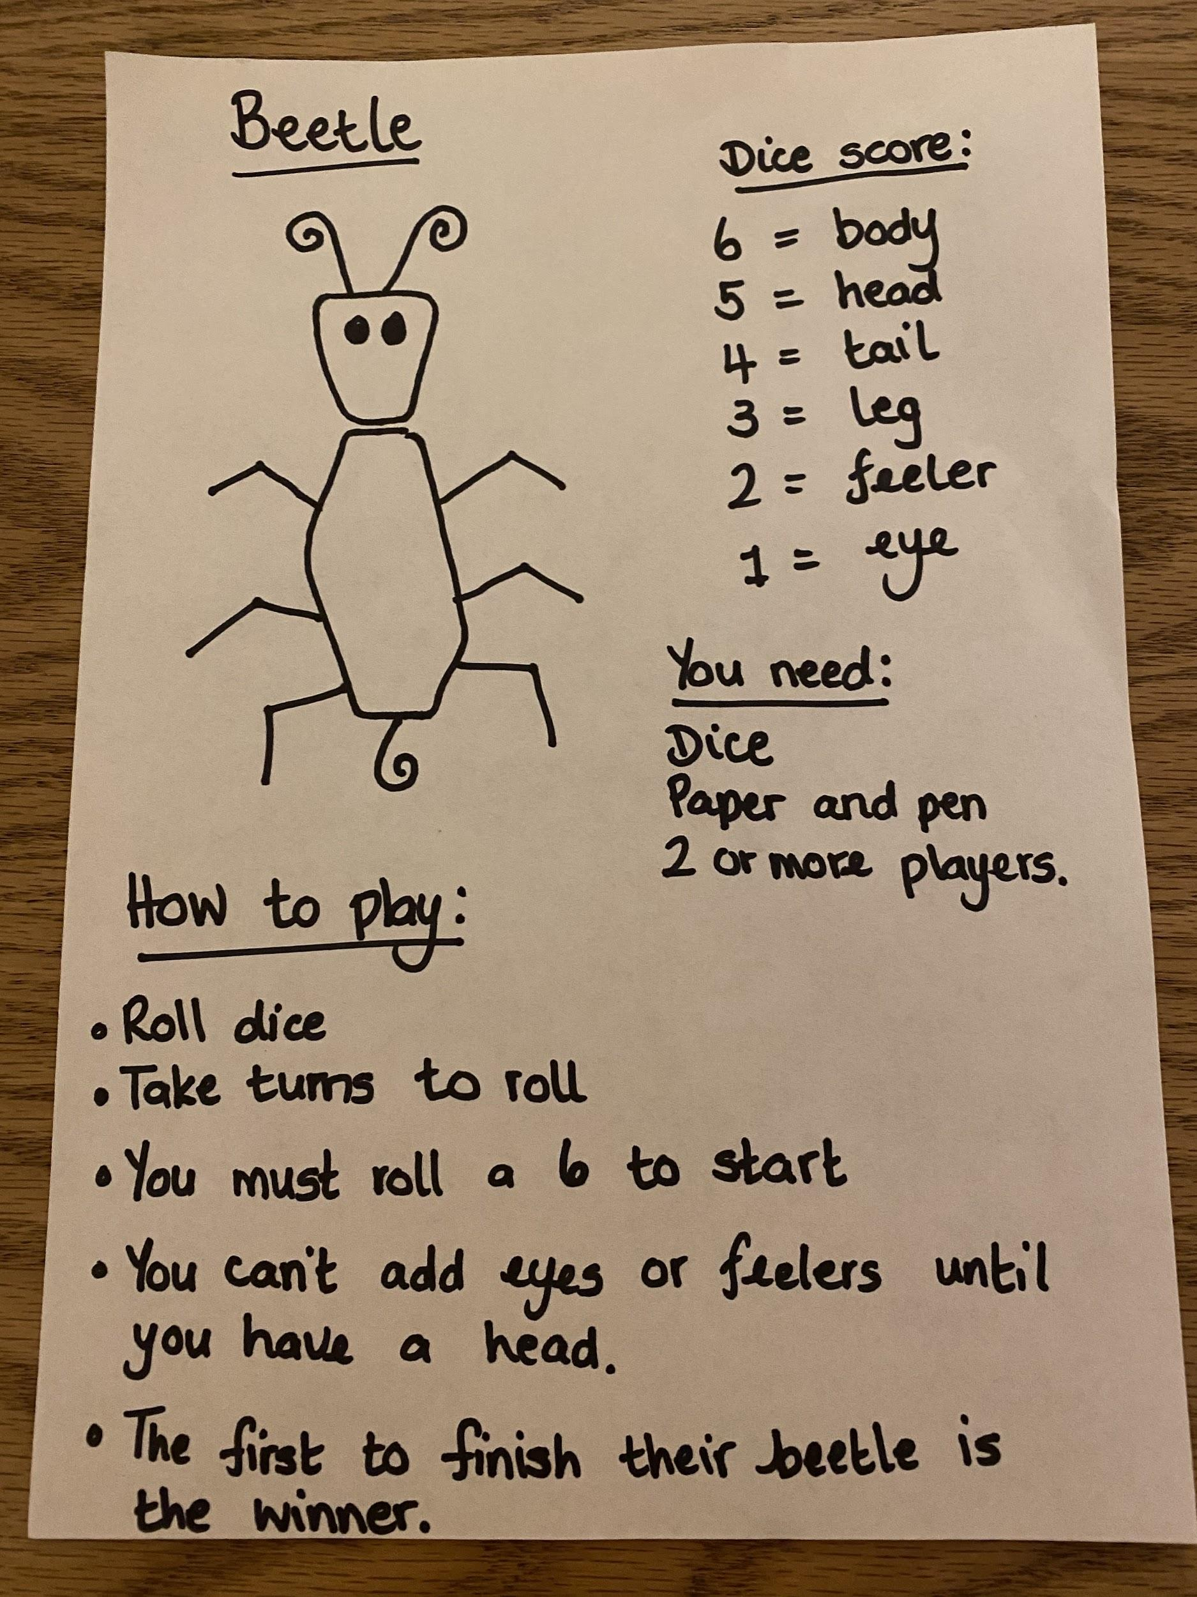

Good luck!

