Scientific Enquiry

A hypothesis is a prediction that is supported with an explanation. The explanation might use previous knowledge.

Consider the following question:

‘Does the distance between the light source and the puppet effect the size of the shadow?’
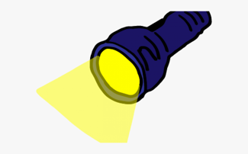
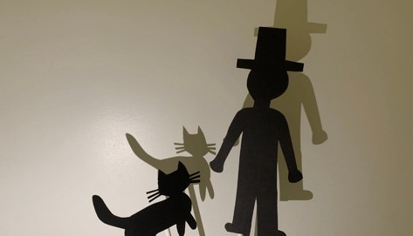

Consider the following:

- Do you think it will make a difference if the light source is far away from the puppet?
- Will the puppet change in size depending on where the light source is?
- What do you need to keep the same when you are changing the distance?
- What do you need to change?

I can set up a simple practical enquiry and consider how to make a test fair.
Consider the following question:

‘Does the distance between the light source and the puppet effect the size of the shadow?’

Planning

Aim (What are you trying to find out?)

I am going to investigate…
…………………………………………………………………………………………………………………………………………………
…………………………………………………………………………………………………………………………………………………
…………………………………………………………………………………………………………………………………………………

Prediction
a) Describe (What do you think will happen?)

I predict that…
…………………………………………………………………………………………………………………………………………………
…………………………………………………………………………………………………………………………………………………
…………………………………………………………………………………………………………………………………………………

b) Use your knowledge and understanding of science to explain why you think this will happen.

I believe this will happen because… …………………………………………………………………………………………………………………………………………………………………………………………………………………………………………………………………………………………………………………………………………………………………………………………………………………………………..

Fair Test

Explain how you will carry out a fair test – What equipment/features are you going to keep the same?

To make sure my investigation is a fair test, I will make sure…
…………………………………………………………………………………………………………………………………………………
…………………………………………………………………………………………………………………………………………………
…………………………………………………………………………………………………………………………………………………
…………………………………………………………………………………………………………………………………………………
…………………………………………………………………………………………………………………………………………………
…………………………………………………………………………………………………………………………………………………

Method

In the space below, list the equipment you will use. Draw a diagram of how you will set up your experiment.

