[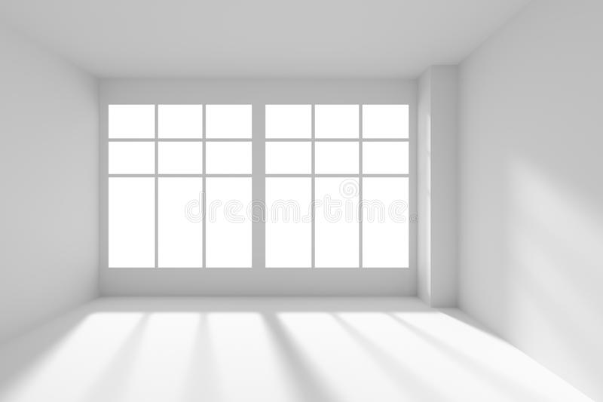](https://www.google.co.uk/url?sa=i&url=https%3A%2F%2Fwww.dreamstime.com%2Fillustration%2Fwhite-empty-room-windows-sunlight-front-view.html&psig=AOvVaw2JpUcsFgXhkS6HWQjJHupK&ust=1605738349158000&source=images&cd=vfe&ved=0CAIQjRxqFwoTCIiOivvPiu0CFQAAAAAdAAAAABAD)