Thursday’s Puzzle:

How many words did you find?

Here are some I found:
At, art, days, dash, darts, hats, has, had, huts, hurts, hardy, rush, rats, rays, rash, rusty, sad, star, sturdy, shut, shard, shady, tray, thud.

Find it Friday (2)

Can you find 8 differences in the photos?
(Apart from my position!)

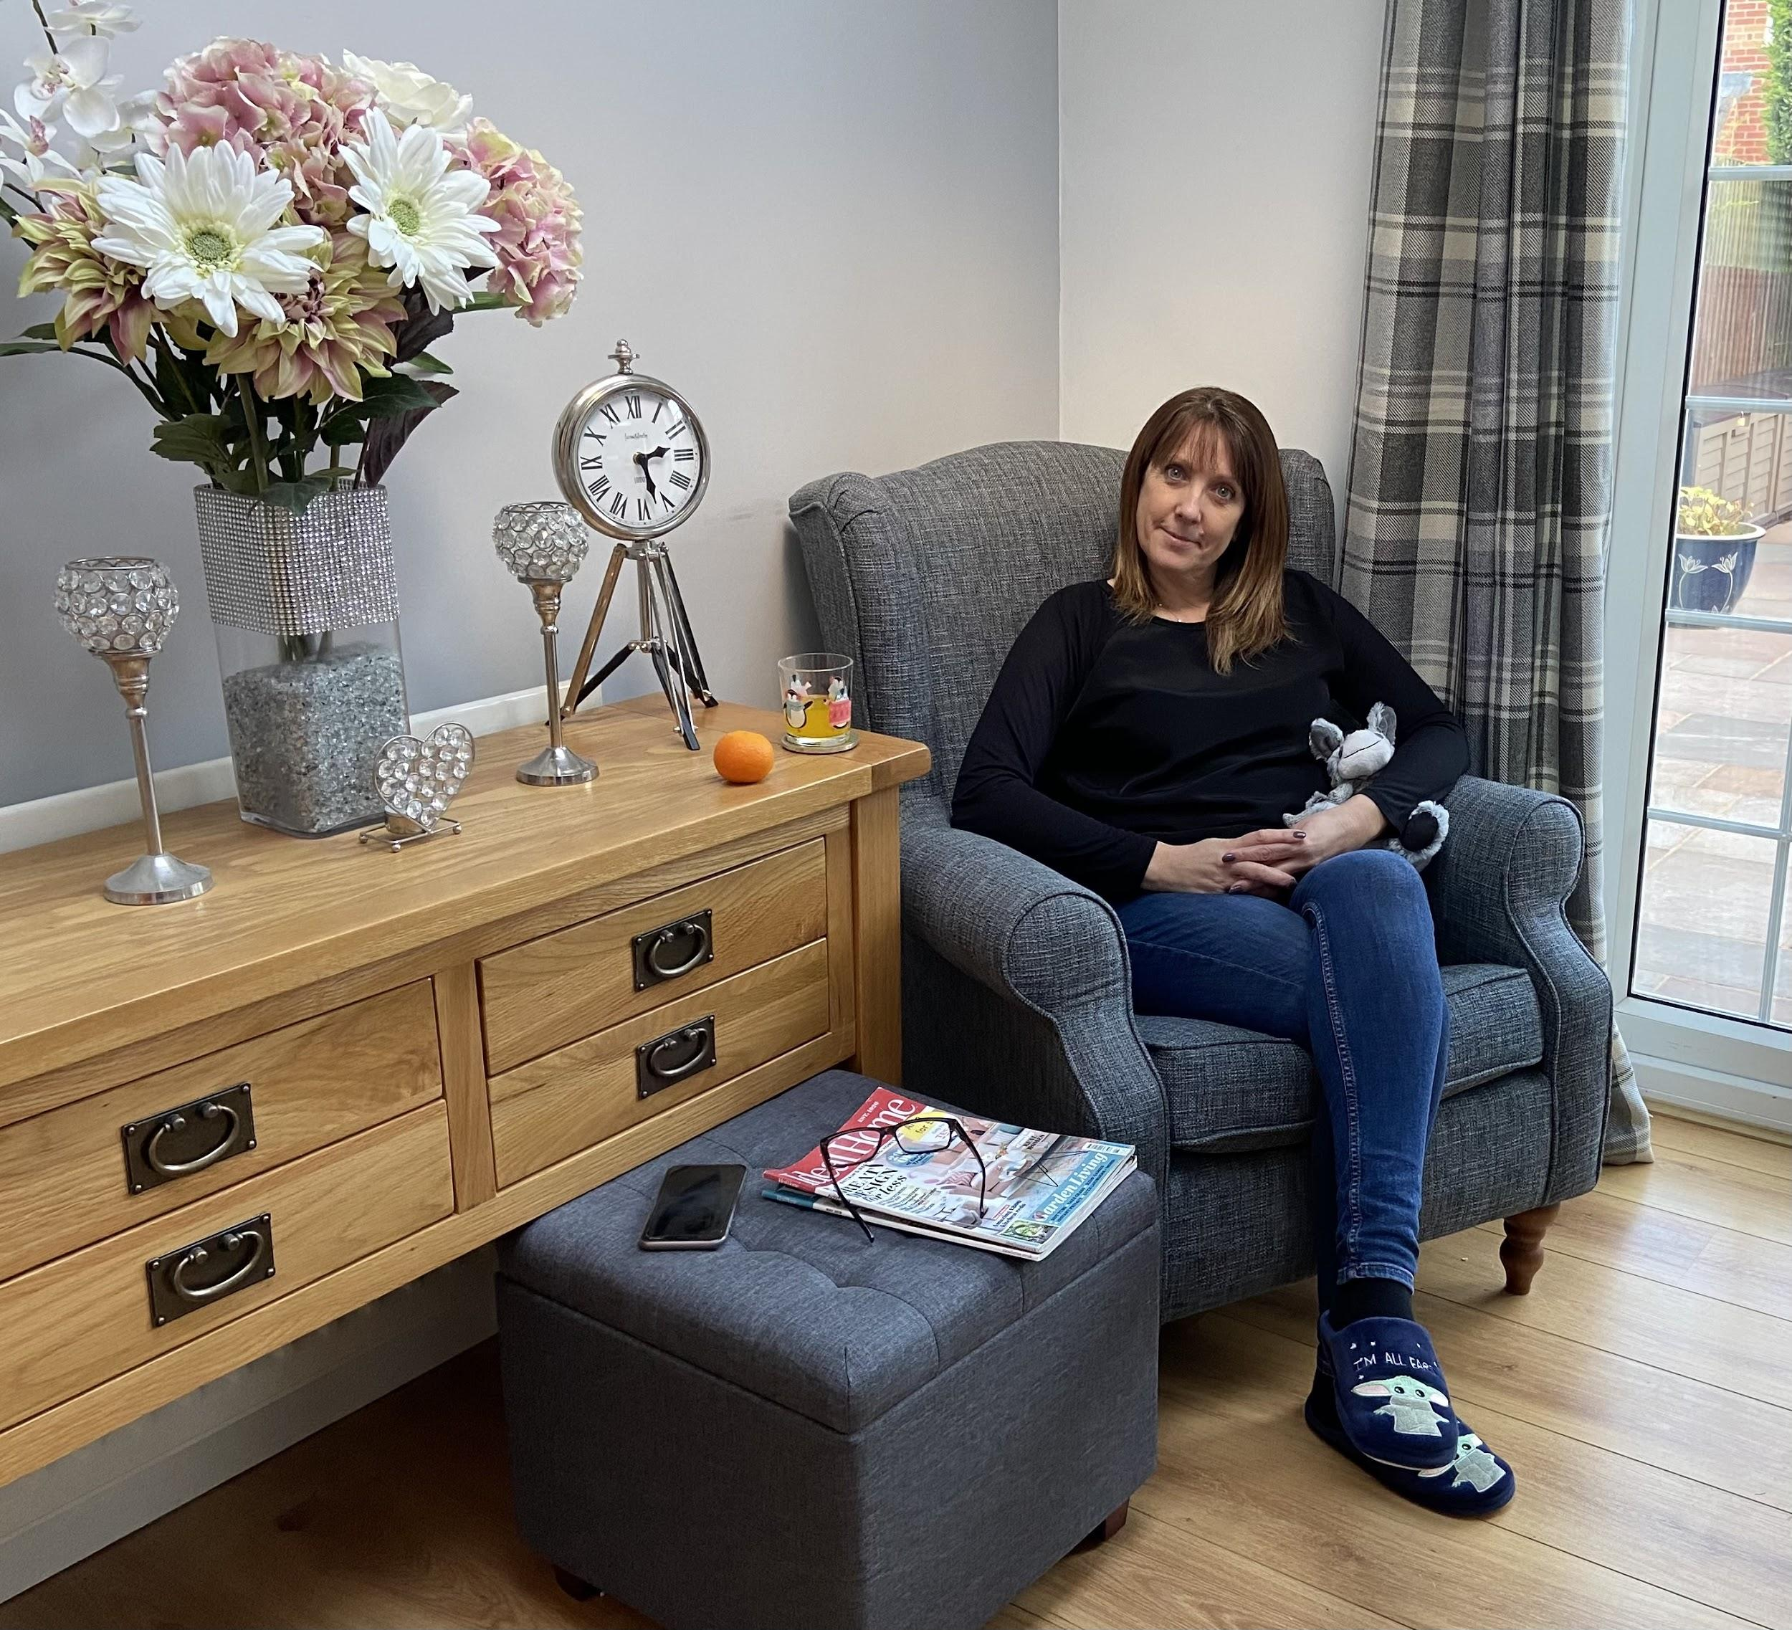

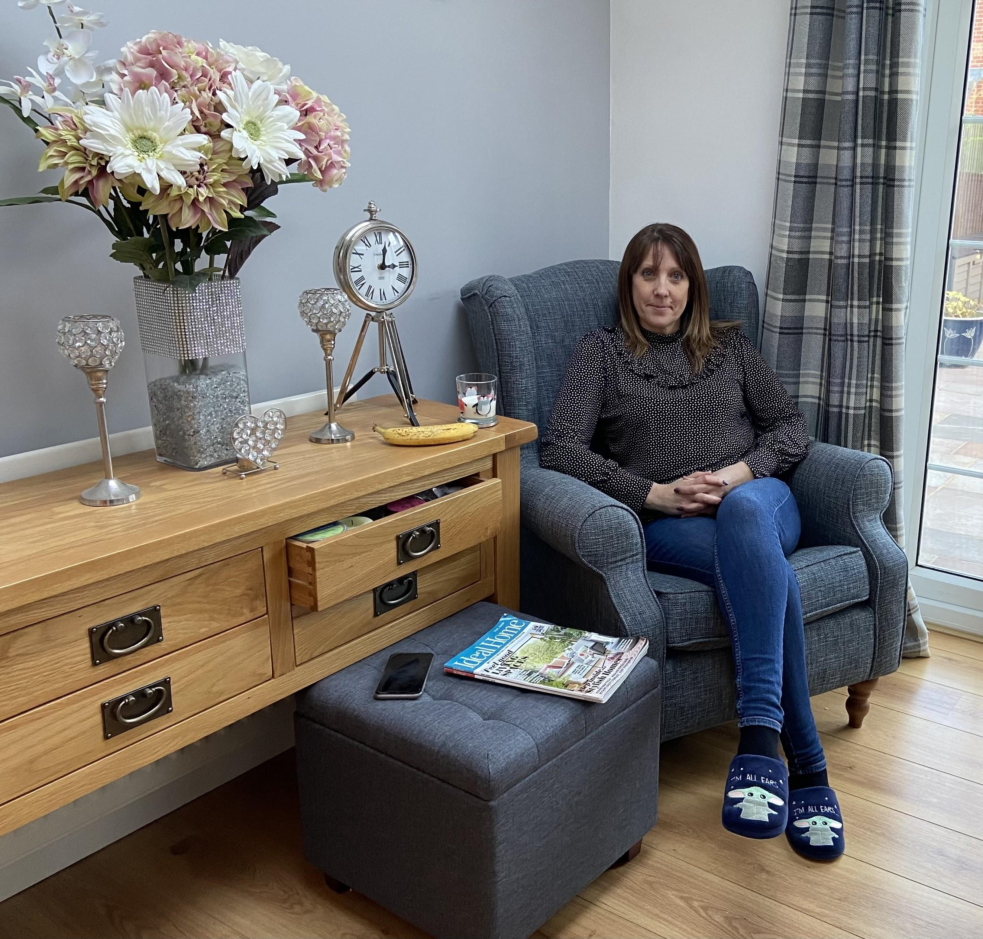

GOOD LUCK !!

