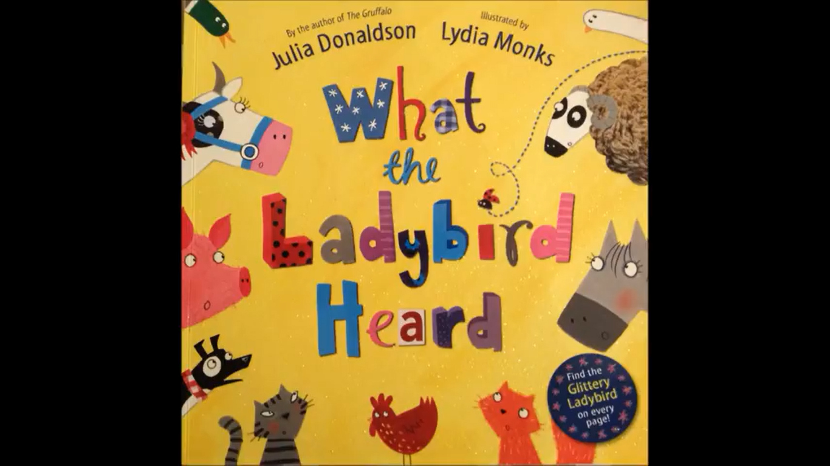
Task: Write adjectives for each animal to predict what you think they will be like in the story

