English- I can write an instructional text

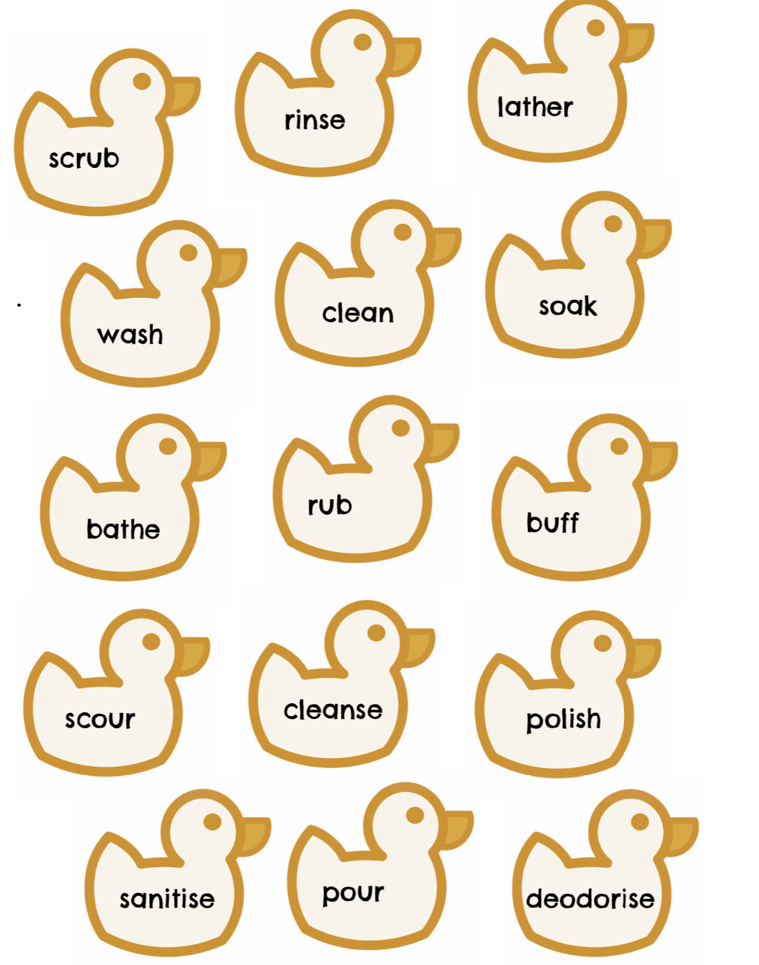
Using your plan from yesterday, begin to write your instructions on How To Wash a Smilodon. Use the following resources below to help you write your instructions.

